**Carleigh D. Ryan R.**

**Keenan S. Curtis S.**

**Jacob K. Teresa M.**

**Brittany G.**

**Exercise 3**

**Team 4**



Network Diagram 3

Defense 6

Production 6

anna 6

chelyabinsk 7

lenin 9

perm 10

starayarussa 12

pskov 14

yakutsk 15

vologda 16

moscow 18

CORP 20

sasha 20

Niet 22

Belenkaya 23

bor 24

tver 26

volsk 29

tula 30

novosibirsk 33

murmansk 35

magnitogorsk 39

nizhniynovgorod 41

chernobyl 42

Ukraine 45

Kiev 47

Reactorone 49

basegi 50

Bear 52

Sales 53

adrik 53

krasnoyarsk 54

bakal 57

vladimir 58

magadan 60

saratov 62

chita 63

stpetersburg 65

samara 67

Cloud 68

novgorod 68

vladivostok 69

astrakhan 70

voronezh 72

bryansk 73

khabarovsk 74

ligma 75

Ipfire 76

mamont 76

beluga 79

mark 79

chatam 83

stoli 84

zyr 85

putinka 86

ruskova 88

offense 89

nmap scans 89

10.4.12.23 92

10.4.8.13 95

10.4.8.13 96

10.4.49.57 99

10.4.49.83 102

10.4.159.65 104

10.4.49.21 111

# Network Diagram

|  |  |  |  |  |  |
| --- | --- | --- | --- | --- | --- |
|  | **Hostname** | **External IP** | **DMZ/Internal IP** | **Services** | **Builder** |
| **Production** | anna | 10.4.55.20 | 192.168.16.20 | DNS, AD | Teresa |
| chelyabinsk | 10.4.55.87 | 192.168.16.87 | DNS, RDP, psexec | Teresa |
| lenin | 10.4.55.19 | 172.16.10.19 | DNS | Keenan |
| perm | 10.4.55.5 | 192.168.16.5 | File Shares, RDP, psexec | Teresa |
| starayarussa | 10.4.55.120 | 192.168.16.120 | RDP, psexec | Teresa |
| pskov | 10.4.55.161 | 172.16.10.161 | IIS, psexec | Keenan |
| yakutsk | 10.4.55.185 | 192.168.20.185 | MySQL, SSH | Keenan |
| vologda | 10.4.55.52 | 172.16.16.52 | Apache, SSH | Teresa |
| moscow | 10.4.55.50 | 192.168.16.50 | MySQL, SSH | Teresa |
| **Corp** | sasha | 10.4.159.32 | 192.168.9.32 | DNS | Ryan |
| omsk | 10.4.159.87 | 192.168.9.65 | MySQL, psexec | Ryan |
| niet | 10.4.159.45 | 172.16.9.25 | AD, DNS | Ryan |
| belenkaya | 10.4.159.33 | 172.16.9.35 | DNS | Ryan |
| tver | 10.4.159.83 | 172.16.13.83 | BIND, SSH | Carleigh |
| volsk | 10.4.159.91 | 192.168.13.91 | BIND | Carleigh |
| tula | 10.4.159.69 | 192.168.13.69 | File Shares, SSH, FTP | Carleigh |
| novosibirsk | 10.4.159.79 | 192.168.9.79 | RDP, psexec | Ryan |
| murmansk | 10.4.159.68 | 172.16.13.68 | Apache, SSH, FTP, Certs | Carleigh |
| magnitogorsk | 10.4.159.190 | 192.168.13.190 | MySQL, SSH | Carleigh |
| nizhniynovgorod | 10.4.159.191 | 172.16.9.54 | IIS, psexec | Ryan |
| bor | 10.4.159.96 | 172.16.13.96 | AD, DNS | Carleigh |
| chernobyl | 10.4.159.12 | 172.16.13.12 | - | Carleigh |
| ukraine | 10.4.159.14 | 172.16.13.14 | - | Carleigh |
| kiev | 10.4.159.15 | 172.16.13.15 | - | Carleigh |
| reactorone | 10.4.159.16 | 172.16.13.16 | - | Carleigh |
| basegi | 10.4.159.30 | 172.16.13.30 | Snort | Carleigh |
| bear | 10.4.159.34 | 192.168.9.12 | Internal IPFire control box | Ryan |
| **Sales** | adrik | 10.4.176.29 | 192.168.14.29 | DNS | Curtis |
| krasnoyarsk | 10.4.176.53 | 172.16.15.53 | BIND, SSH | Brittany |
| bakal | 10.4.176.183 | 192.168.15.183 | BIND | Brittany |
| vladimir | 10.4.176.175 | 192.168.15.175 | SSH, FTP | Brittany |
| magadan | 10.4.176.196 | 172.16.11.196 | IIS, psexec | Jacob |
| saratov | 10.4.176.160 | 192.168.11.160 | MySQL, psexec | Jacob |
| chita | 10.4.176.141 | 172.16.14.141 | Apache, SSH | Curtis |
| stpetersburg | 10.4.176.12 | 192.168.14.12 | MySQL, SSH | Curtis |
| samara | 10.4.176.122 | 192.168.15.122 | SSH | Brittany |
| **Cloud** | novgorod | 10.4.161.93 | 192.168.8.93 | DNS, psexec | Curtis |
| vladivostok | 10.4.161.63 | 192.168.8.63 | File Shares, psexec | Curtis |
| astrakhan | 10.4.161.212 | 172.16.8.212 | IIS, SSH | Jacob |
| voronezh | 10.4.161.79 | 192.168.8.79 | MySQL, SSH | Jacob |
| bryansk | 10.4.161.228 | 172.16.8.228 | IIS, psexec | Keenan |
| khabarovsk | 10.4.161.163 | 192.168.8.163 | MySQL, psexec | Keenan |
| ligma | 10.4.161.55 | 192.168.8.55 | AD | Curtis |

|  |  |  |  |  |  |
| --- | --- | --- | --- | --- | --- |
|  | **Hostname** | **External IP** | **DMZ Gateway** | **Internal Gateway** | **Builder** |
| **IPFire** | Mamont.corp.team4.tu | 10.4.159.9 | 172.16.9.1 | 192.168.9.1 | Ryan |
| beluga.corp.team4.tu | 10.4.159.13 | 172.16.13.1 | 192.168.13.1 | Carleigh |
| chatam.cloud.team4.tu | 10.4.90.8 | 172.16.8.1 | 192.168.8.1 | Curtis |
| stoli.sales.team4.tu | 10.4.176.14 | 172.16.14.1 | 192.168.14.1 | Curtis |
| zyr.sales.team4.tu | 10.4.176.15 | 172.16.15.1 | 192.168.15.1 | Brittany |
| putinka.sales.team4.tu | 10.4.176.11 | 172.16.11.1 | 192.168.11.1 | Jacob |
| Mark.production.team4.tu | 10.4.55.16 | 172.16.16.1 | 192.168.16.1 | Teresa |
| ruskova.production.team4.tu | 10.4.55.10 | 172.16.10.1 | 192.168.10.1 | Keenan |

|  |  |  |
| --- | --- | --- |
|  | **IP Address** | **Builder** |
| **Kali** | 10.4.12.23 | Jacob |
| 10.4.8.10 | Curtis |
| 10.4.8.13 | Curtis |
| 10.4.49.83 | Teresa |
| 10.4.49.57 | Brittany |
| 10.4.49.21 | Keenan |
| 10.4.159.65 | Ryan |

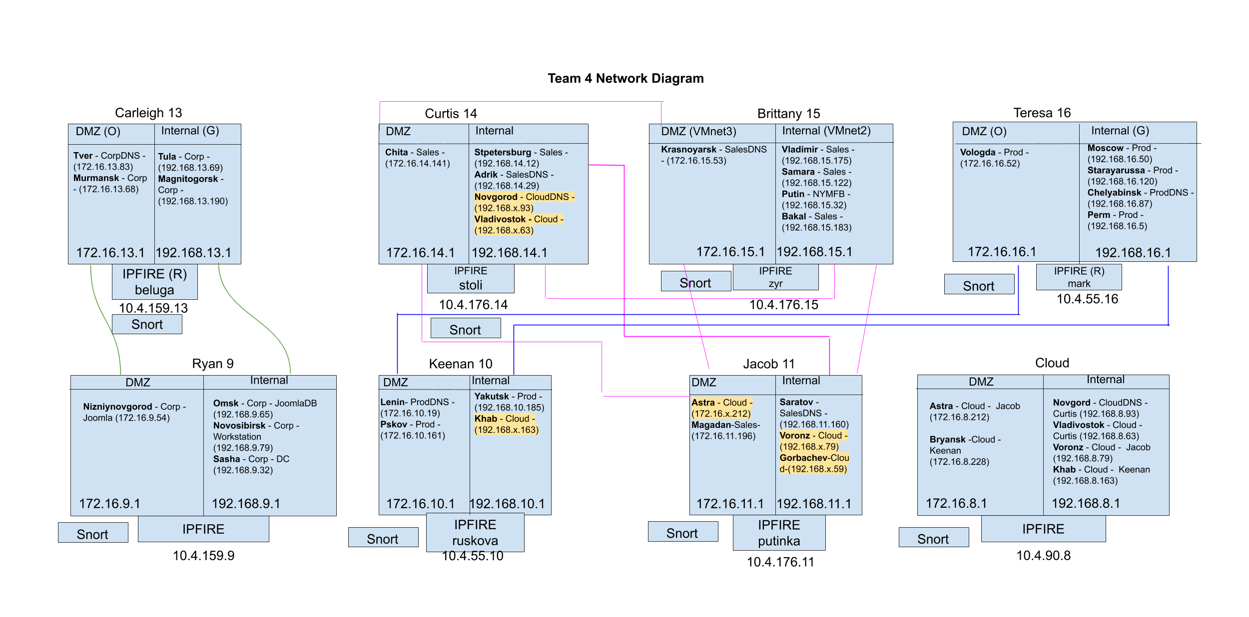

# Defense

## Production

### anna

**System Builder:** Teresa Melgarejo

**Role:** Domain Controller/DNS

**IP Address:** 10.4.55.20

**Production:**

This Windows Server 2016 system was built on the internal network to be a domain controller of the systems that I was responsible for, to allow for efficient management of users and their passwords. In order to accomplish this, this system was also made into a small DNS, with only the systems it was overseeing on the server, using DMZ IPs and Internal IPs. This system also included remote services such as WinRM, psexec, and RDP.

**Hardening:**

Through Group Management Policy, we disabled SMB1, the Account Lockout Policy was set to lockout a user at the third failed login attempt for 75 minutes on the first day, and disabled LLMNR. The user “zathras” was deleted, and created a new user, mstevens, with administrator privileges, giving mstevens a unique and technically difficult password. The firewall was confirmed to be on as well.

The only change to the Group Policy was changing the Account Lockout Policy lockout time to 2 hours on Day 2.

**System Performance During Exercise:**

This system was not being checked by Nagios, but the system did well and didn’t go down at any time.

**Post-Activity Log Analysis:**

There was nothing of interest that occured in the logs.

### chelyabinsk

**System Builder:** Teresa Melgarejo

**Role:** Internal DNS

**IP Address:** 10.4.55.87

**Production:**

This Windows Server 2016 system was built on the internal network to be a DNS of any of the systems in Cloud, Sales, and Production, using external IPs. This system also included remote services such as WinRM, psexec, and RDP.

**Hardening:**

This system was joined to the system’s, Anna, domain, so the same hardening happening to Anna, happened to Chelyabinsk.

Through Group Management Policy, we disabled SMB1, the Account Lockout Policy was set to lockout a user at the third failed login attempt for 75 minutes on the first day, and disabled LLMNR. The user “zathras” was deleted, and created a new user, mstevens, with administrator privileges, giving mstevens a unique and technically difficult password. The firewall was confirmed to be on as well.

The only change to the Group Policy was changing the Account Lockout Policy lockout time to 2 hours on Day 2.

**System Performance During Exercise:**

On Nagios, the services RDP Basic Check and Windows remote administration via psexec weren’t working properly due to flapping, which is possibly due to the DNS taking too long to resolve the IP and or hostname. Although those two services on Nagios were flapping, they were tested and showed to be configured and functional.

**Post-Activity Log Analysis:**

|  |  |  |  |  |  |
| --- | --- | --- | --- | --- | --- |
| **Time** | **Offending IP/Team** | **Repeated attempts** | **Information** | **Image Number** | |
| 5/15 6:34:49 | 10.1.185.104/Team 1 |  | Attempt to log in as CEO sbrooks | | 1 |
| 5/15 6:34:52 | 10.5.222.109/Team5 | 6:36:18; 6:37:54; 6:36:38 | Attempt to log in as CEO sbrooks | | 2 |
| 5/15 7:14:21 | 10.5.222.109/Team 5 | 7:14:51; 7:15:07 | Attempt to log in as bjohnston | | 3 |

**1**

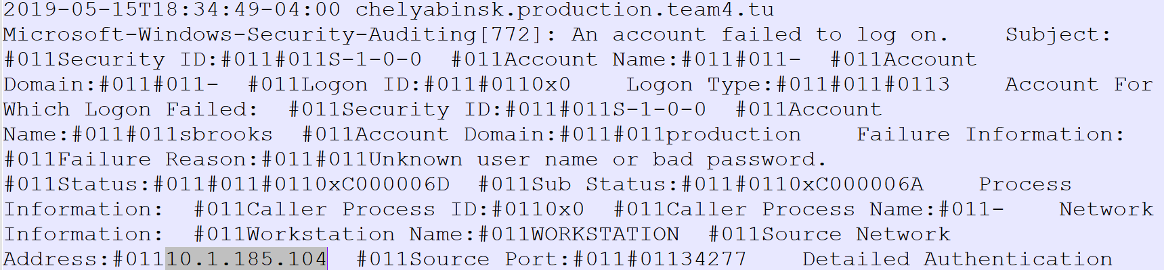

**2**

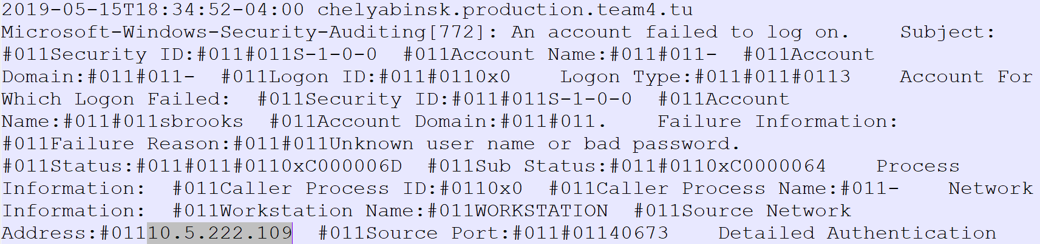

**3**

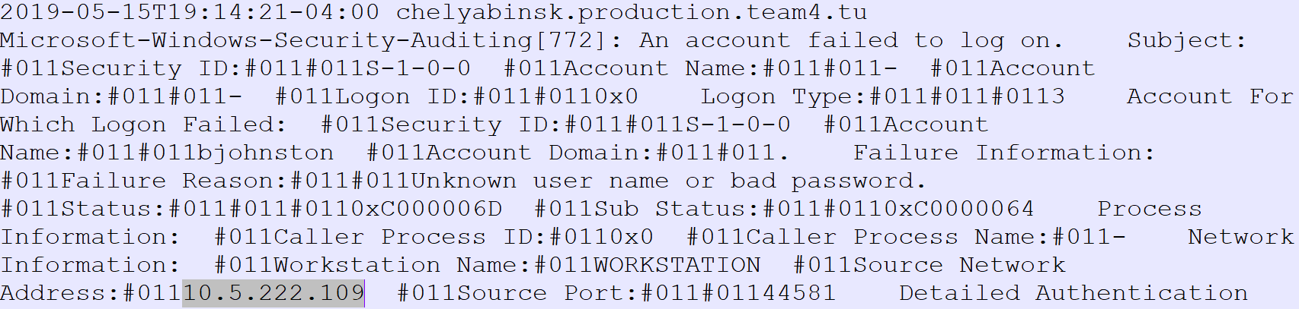

### lenin

**System Builder:** Keenan Starstrom

**Role:** DMZ DNS

**IP Address:** 10.4.55.19

**Production:**

This machine was a Windows 2016 server set up as a DMZ DNS server for my systems

**Hardening:**

Hardening steps taken for this box were to remove the zathras account, change the administrator password, ensure the firewall was enabled and configured, SMB1 was disabled, and the account lockout policy was set up.

**System Performance During Exercise:**

The system was not being checked by Nagios, but performed fine over both days of the exercise, with no interruptions in functionality.

**Post-Activity Log Analysis:**

Only activity seen in the logs for this box are either pings or failed authentication attempts, no real notable attack instances.

### perm

**System Builder:** Teresa Melgarejo

**Role:** File Server

**IP Address:** 10.4.55.5

**Production:**

The Windows Server 2012R2 was built to be a file server on the internal network. The system was set up to allow the CEO and production user to access the File Share (C:\Shares\CommonShare\sharetest) document “sharetest”. This system also included remote services such as WinRM, psexec, and RDP.

**Hardening:**

This system was joined to the system’s, Anna, domain, so the same hardening happening to Anna, happened to Perm.

Through Group Management Policy, we disabled SMB1, the Account Lockout Policy was set to lockout a user at the third failed login attempt for 75 minutes on the first day, and disabled LLMNR. The user “zathras” was deleted, and created a new user, mstevens, with administrator privileges, giving mstevens a unique and technically difficult password. The firewall was confirmed to be on as well.

The only change to the Group Policy was changing the Account Lockout Policy lockout time to 2 hours on Day 2.

**System Performance During Exercise:**

The system performed well. There were no services that went down during the exercise.

**Post-Activity Log Analysis:**

|  |  |  |  |  |  |
| --- | --- | --- | --- | --- | --- |
| **Time** | **Offending IP/Team** | **Repeated attempts** | **Information** | **Image Number** | |
| 5/15 5:19:07 | 10.5.222.109/Team 5 |  | Attempt to log in as unknown user rdvwaVzR | | 1 |
| 5/15 5:20:33 | 10.5.222.109/Team 5 | 5:20:48; 5:21:24 | Attempt to log in as CEO sbrooks | | 2 |

**1**

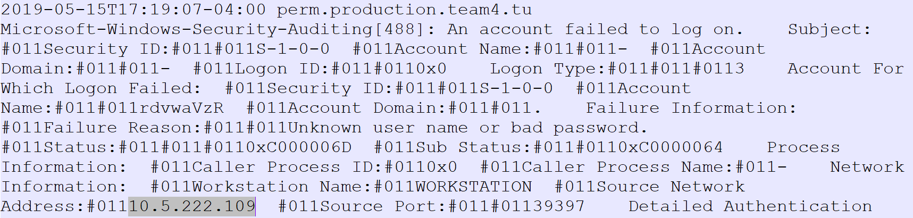

**2**

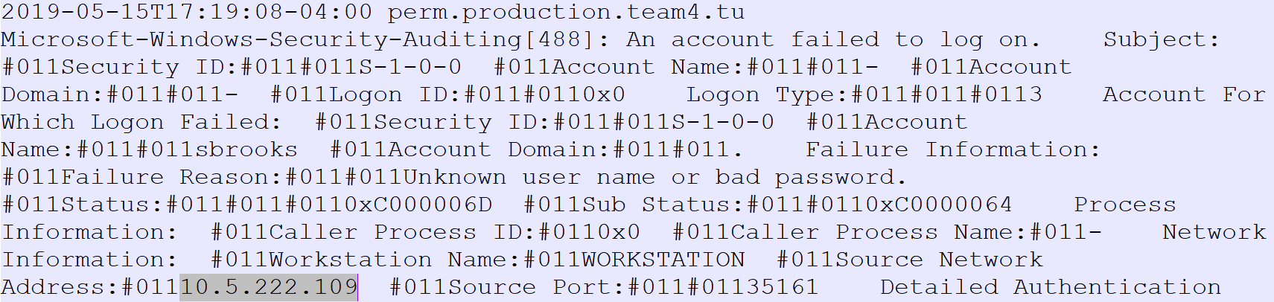

### starayarussa

**System Builder:** Teresa Melgarejo

**Role:** Windows Workstation

**IP Address:** 10.4.55.120

**Production:**

The Windows 8.1 workstation was built on the internal network to allow user, cward, access to the system and check if the MD5 sum of file C:\Team4Personal.csv was proper. This system also included remote services such as WinRM, psexec, and RDP.

**Hardening:**

This system was joined to the system’s, Anna, domain, so the same hardening happening to Anna, happened to Starayarussa.

Through Group Management Policy, we disabled SMB1, the Account Lockout Policy was set to lockout a user at the third failed login attempt for 75 minutes on the first day, and disabled LLMNR. The user “zathras” was deleted, and created a new user, mstevens, with administrator privileges, giving mstevens a unique and technically difficult password. The firewall was confirmed to be on as well.

The only change to the Group Policy was changing the Account Lockout Policy lockout time to 2 hours on Day 2.

**System Performance During Exercise:**

The system performed well. There were no services that went down during the exercise.

Although no services went down, on day one, we received an email from dorfl.classex.tu(which is team 5) asking us to upgrade our version of firefox, as shown below:

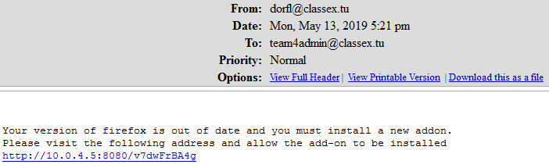

When we attempted to install the new addon the connection timed out as shown below:

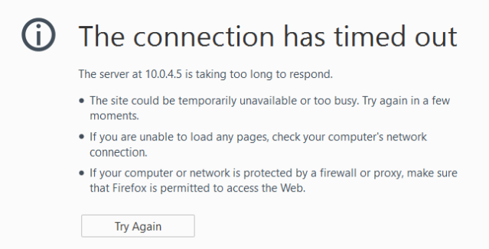

Besides initializations for the user, cward, when we logged on, nothing related to the installation of the firefox addon was noted in the logs.

### pskov

**System Builder:** Keenan Starstrom

**Role:** Wordpress Server

**IP Address:** 10.4.55.161

**Production:**

This system was a Windows 2012 server set up as a web server for a Wordpress 3.5 site using IIS. The system was configured to serve web pages over both http and https, as well as a wordpress site. It was also set up to allow domain admins to access wit via WinRM and psexec.

**Hardening:**

Hardening steps taken for this box were to remove the zathras account, change the administrator password, ensure the firewall was enabled and configured, SMB1 was disabled, and the account lockout policy was set up.

**System Performance During Exercise:**

The system mostly performed well during the exercise, however while the regular web pages functioned fine the wordpress site was never fully functional due to difficulties with setting it up, outside of this and the WinRM account not authenticating despite being a domain admin account, the machine stayed online for the entirety of both days.

**Post-Activity Log Analysis:**

Log analysis did not find anything more than pings and some failed authentication attempts, the hardening done to the box was sufficient to keep it from succumbing to attacks.

### yakutsk

**System Builder:** Keenan Starstrom

**Role:** Wordpress Database

**IP Address:** 10.4.55.185

**Production:**

This machine was a Mint 13 system functioning as the MySql database for pskov’s wordpress site. This mean it of course needed MySql installed and configured, as well as SSH.

**Hardening:**

Hardening steps taken for this box were to remove the zathras account, change the root password, ensure the firewall was enabled and configured, disabling the ability to SSH as root, and setting up fail2ban to prevent brute force attempts.

**System Performance During Exercise:**

The system performed fine over both days of the exercise, never having a service go down.

**Post-Activity Log Analysis:**

Log analysis did not find anything more than pings and some failed authentication attempts, the hardening done to the box was sufficient to keep it from succumbing to attacks.

### vologda

**System Builder:** Teresa Melgarejo

**Role:** Joomla 3.6.0

**IP Address:** 10.4.55.52

**Production:**

The CentOS 7 system was built on the internal network to support Joomla. Joomla users included lstephens, dhunt, and hmartin. The other services set up for this system was SSH for users, sbrooks and rblack, Apache web pages - general, ssl, and secret. The secret Apache webpage was set up to only allow authorized users to access it. This system was able to download a CA certificate from a system in the Corp domain, murmansk. The certificate in the system was signed by the CA signer of the network.

**Hardening:**

The default administrator ‘zathras’ was deleted. The user, root, was given a unique and technically-difficult password. The ability to SSH as root was disabled, and the firewall was enabled as well. SSHGuard was also installed and enabled on the system.

**System Performance During Exercise:**

On the first day of the exercise, only the Joomla check was down since we couldn’t set up on time, but the check was up and running for the second day.

Besides the Joomla check, the other other checks and never went down. Overall, the system performed well. There were no services that went down during the exercise.

**Post-Activity Log Analysis:**

|  |  |  |  |  |  |
| --- | --- | --- | --- | --- | --- |
| **Time** | **Offending IP/Team** | **Repeated attempts** | **Information** | **Image Number** | |
| 5/13 5:39:01 | 10.1.185.101/Team 1 |  | Attempt to SSH in as nonexistent user zathras | | 1 |
| 5/13 6:02:00 | 10.1.185.101/Team 1 |  | Attempt to SSH in as root | | 2 |
| 5/15 5:27:45 | 10.1.185.14/Team 1 |  | Attempt to SSH in as nonexistent user zathras | | 3 |
| 5/15 6:37:53 | 10.1.185.101/Team 1 | 6:39:18 | Attempt to SSH in as root | | 4 |

**1**



**2**



**3**



**4**



### moscow

**System Builder:** Teresa Melgarejo

**Role:** Joomla Database

**IP Address:** 10.4.55.50

**Production:**

The CentOS 6.8 system was built on the internal network to support the Joomla Database by using MySQL. The other services set up for this system was SSH for users, ggriffin and bjohnston.

**Hardening:**

The default administrator ‘zathras’ was deleted. The user, root, was given a unique and technically-difficult password. The ability to SSH as root was disabled, and the firewall was enabled as well. SSHGuard was also installed and enabled on the system.

**System Performance During Exercise:**

The system performed well. There were no services that went down during the exercise.

**Post-Activity Log Analysis:**

|  |  |  |  |  |  |
| --- | --- | --- | --- | --- | --- |
| **Time** | **Offending IP/Team** | **Repeated attempts** | **Information** | **Image Number** | |
| 5/13 5:41:28 | 10.1.185.101/Team 1 |  | Attempt to SSH in as nonexistent user zathras | | 1 |
| 5/13 6:04:27 | 10.1.185.101/Team 1 |  | Attempt to SSH in as root | | 2 |
| 5/15 5:27:55 | 10.1.185.14/Team 1 |  | Attempt to SSH in as zathras | | 3 |
| 5/15 6:38:02 | 10.1.185.101/Team 1 | 18:39:28 | Attempt to SSH in as root | | 4 |
| 5/15 6:41:41 | 10.1.185.101/Team 1 |  | Attempt to SSH in as zathras | | 5 |
| 5/15 5:56:38 | 10.2.72.154/Team 2 |  | Attempt to SSH in as nonexistent user oks | | 6 |

**1**



**2**



**3**



**4**



**5**



**6**



## CORP

### sasha

**System Builder:** Ryan Russell

**Role: Internal** AD & DNS

**IP Address:** 10.4.159.32

**Production:**

This was a Windows 2016 Server on the Corp internal (green) network. This machine was created as an optional system to serve as the CORP internal network AD and DNS server. As such, there were no Nagios checks on it.

**Hardening:**

Since this server was the main (and only) AD server for the CORP internal network, the Group Policies I created to harden all the computers in the domain were implemented here. These included enabling the lockout policy for account access, shortening the lockout duration, in-case of accidental lockout, and lowering the lockout threshold to two failed login attempts. I also implemented group policies regarding firewall settings. I enabled psexec access, since that was required on all my machines. However, I also used psesxec with a powershell command to disable SMB1 on all my windows machines.

**System Performance During Exercise:**

This system performed well and, to my knowledge, was not compromised during the exercise.

**Post-Activity Log Analysis:**

There were no incorrect login attempts, or any other kind of suspicious activity on this host.

**Omsk**

**System Builder:** Ryan Russell

**Role: Internal** Joomla Database

**IP Address:** 10.4.159.87

**Production:**

This was a Windows 2008 R2 Server on the Corp internal (green) network. It was required to have mySQL installed, a database created, a specifically named table added, and to make it accessible by a particular user using the relevant password stored in Nagios in order to pass the Nagios checks.

**Hardening:**

To harden this machine, I first changed all passwords, then removed the local Zathras user from the Admin group, followed by removing the user entirely. I then joined this machine to the corp.team4.tu domain and the domain controller sasha.corp.team4.tu. Further hardening was done through the application of group policies as detailed in the sasha machine’s Hardening section.

**System Performance During Exercise:**

This system performed well and, to my knowledge, was not compromised during the exercise.

**Post-Activity Log Analysis:**

There were no incorrect login attempts, or any other kind of suspicious activity on this host.

### 

### Niet

**System Builder:** Ryan Russell

**Role:** DMZ AD & DNS

**IP Address:** 10.4.159.45

**Production:**

This was a Windows 2016 Server on the Corp DMZ (orange) network. This machine was created as an optional system to serve as the CORP DMZ network AD and DNS server. As such, there were no Nagios checks on it.

**Hardening:**

Since this server was the main (and only) AD server for the CORP internal network, the Group Policies I created to harden all the computers in the domain were implemented here. These included enabling the lockout policy for account access, shortening the lockout duration, in-case of accidental lockout, and lowering the lockout threshold to two failed login attempts. I also implemented group policies regarding firewall settings. I enabled psexec access, since that was required on all my machines. However, I also used psesxec with a powershell command to disable SMB1 on all my windows machines.

**System Performance During Exercise:**

This system performed well and, to my knowledge, was not compromised during the exercise.

**Post-Activity Log Analysis:**

There were no incorrect login attempts, or any other kind of suspicious activity on this host.

### Belenkaya

**System Builder:** Ryan Russell

**Role: Internal** DMZ DNS

**IP Address:** 10.4.159.33

**Production:**

This was a CentOS 7 Server on the Corp DMZ (orange) network. I initially intended to use this as the only DNS server on my DMZ network. However, I realized that some of the checks on Nizhniynovgorod.corp.team4.tu would not work unless the users that were being used by Nagios to login were domain users on the CORP domain. So, created the AD and DNS server Niet. However, since this was already in-place and functioning, I decided to leave it as a backup DNS server.

**Hardening:**

To harden this machine, I immediately changed the passwords for the Zathras and root users, followed by creating another user in the wheel group (giving sudo permission), and concluding with the deletion of the Zathras user. I then installed Fail2Ban, and configured it for SSH protection. While important, this turned out to be redundant, as I was able to shut down all incoming ports except TCP/UDP 53 to allow DNS traffic through.

**System Performance During Exercise:**

This system performed well and, to my knowledge, was not compromised during the exercise.

**Post-Activity Log Analysis:**

As with many of my other systems, there were no unauthorized and/or unsuccessful login attempts on this machine.

### 

### bor

**System Builder:** Carleigh Duncan

**Role**: Domain Controller/DNS

**IP** **Address**: 10.4.159.96

**Production**:

This Windows Server 2012R2 system was built to be a domain controller of the systems that I was responsible for, to allow for efficient management of users and their passwords. In order to accomplish this, this system was also made into a small DNS, with only the systems it was overseeing on the server.

On the second day, it was found that this system was not functioning correctly, as although the connection with each box had been established and they were all part of the domain, the passwords could not be changed through the DC. As a result, the system was not furthered. It remained on the network in case it could be used as a malware workstation.

Active Directory was uninstalled the second day.

**Hardening**:

SMB1 was disabled on this machine. The administrator ‘zathras’ was deleted, and the new administrator, tcruz, was given a unique and technically difficult password. The firewall was confirmed to be on as well.

**System Performance During Exercise:**

littlebottom@classex.tu (team 2) sent an email (addressed to one of our team members) with a text file as an attachment. The contents of the file are also shown below.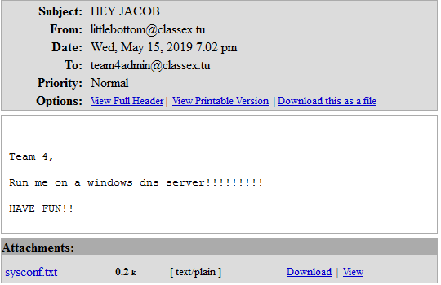

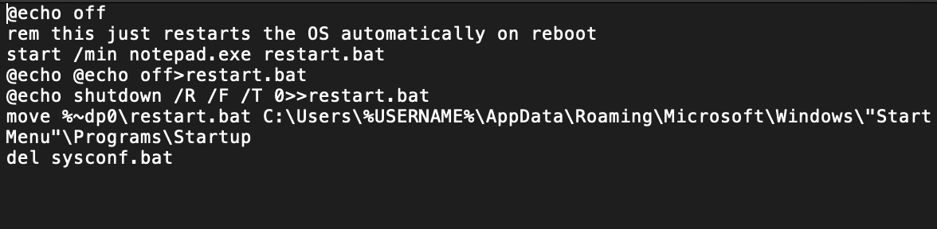

This above text was copied into PowerShell but it didn’t run correctly. Only the first line ran correctly. This is likely due to each line being escaped. In hindsight, the sender probably wanted me to run the text file as an executable, not just copy and paste the contents into PowerShell.

### tver

**System Builder:** Carleigh Duncan

**Role**: DMZ DNS

**IP Address:** 10.4.159.83

**Production**:

This Ubuntu 16.04 system was built as the DMZ DNS. All the IP addresses used in this DNS were the external IP addresses. The system was also set up to allow the users kwatkins and phoward to SSH into the system. In addition, the CEO, as well as all IT and Corp staff were added to the system.

**Hardening**:

The default administrator ‘zathras’ was deleted and replaced with an innocuous-looking user tcruz. This user, as well as root, were each given a unique and technically-difficult password. The ability to SSH as root was disabled, and the firewall was enabled as well. SSHGuard was also installed on the system and programmed to block an IP after 3 incorrect attempts.

**System Performance During Exercise:**

This system performed well. There were no services that went down during the exercise.

**Post-Activity Log Analysis:**

|  |  |  |  |  |  |
| --- | --- | --- | --- | --- | --- |
| **Time** | **Offending IP/Team** | **Repeated attempts** | **Information** | **Image Number** | |
| 5/13 5:41:57 | 10.1.185.101/Team 1 |  | Attempt to SSH in as nonexistent user zathras | | 1 |
| 5/13 5:47:49 | 10.1.185.13/Team 1 |  | Attempt to SSH in as root | | 2 |
| 5/13 5:47:51 | 10.1.185.13/Team 1 |  | Attempt to SSH in as nonexistent user zathras | | 3 |
| 5/13 6:09:58 | 10.2.72.59/Team 2 |  | Nmap scan by Team 2 | | 4 |
| 5/15 5:27:42 | 10.1.185.14/Team1 | 5:27:44; 5:27:53; 5:27:55 | Attempt to SSH in as nonexistent user zathras | | 5 |
| 5/15 5:27:55 | 10.1.185.14/Team 1 |  | Attempt to SSH in as root | | 6 |
| 5/15 5:46:45 | 10.0.6.250/Red Team | 5:51:36 | Attempt to SSH in as nonexistent user mwelch | | 7 |
| 5/15 5:53:17 | 10.0.6.250/Red Team |  | Attempt to SSH in as nonexistent user ccunningham | | 8 |
| 5/15 6:10:44 | 10.2.72.88/Team 2 | 6:11:45; 6:17:17; 6:18:42 | Nmap scan by Team 2 | | 9 |
| 5/15 6:28:09 | 10.0.6.250/Red Team |  | Attempt to SSH in as nonexistent user hpeterson | | 10 |
| 5/15 6:33:43 | 10.2.72.89/Team 2 |  | Nmap scan by Team 2 | | 11 |
| 5/15 6:39:31 | 10.1.185.101/Team 1 |  | Attempt to SSH in as root | | 12 |
| 5/15 6:41:40 | 10.1.185.101/Team 1 | 6:41:42; 6:41:44 6:41:47; 6:41:47; 6:41:52 | Attempt to SSH in as nonexistent user zathras | | 13 |

**1**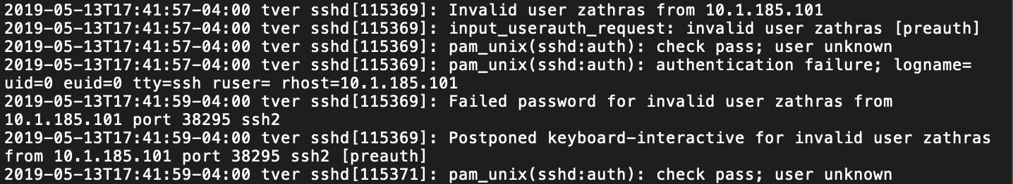

**2**

**3**

**4**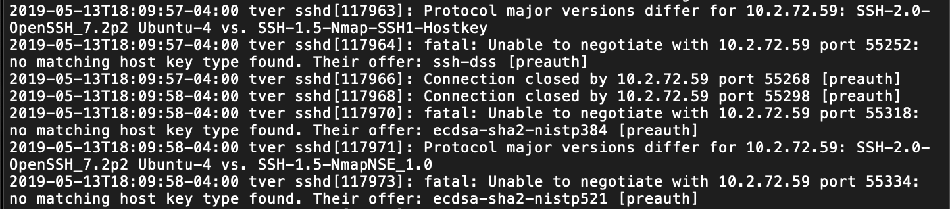

**5** 

**6**

**7**

**8**

**9**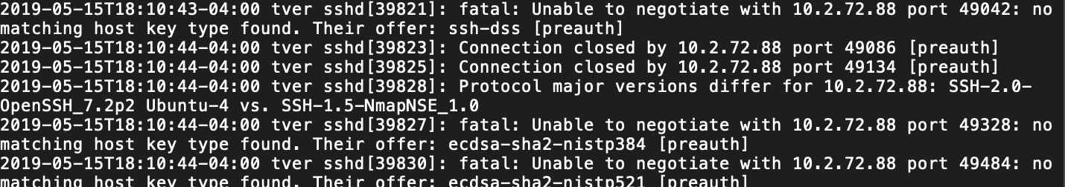

**10**

**11**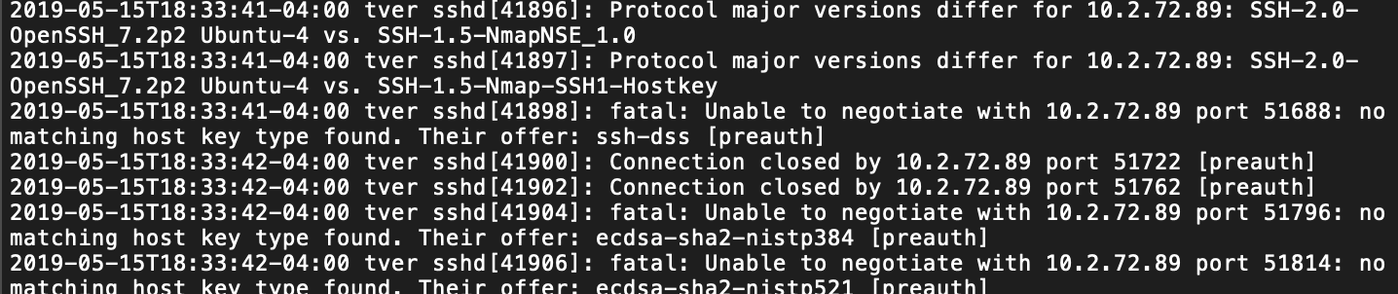

**12**

**13**

### volsk

**System Builder**: Carleigh Duncan

**Role**: Internal DNS

**IP Address**: 10.4.159.91

**Production**:

This Ubuntu 14.04 system was configured as an Internal DNS. The IP addresses used in this DNS were all internal IP addresses.

**Hardening**:

The default administrator ‘zathras’ was deleted and replaced with an innocuous-looking user tcruz. This user, as well as root, were each given a unique and technically-difficult password. The ability to SSH as root was disabled, and the firewall was enabled as well. SSHGuard was also installed on the system and programmed to block an IP after 3 incorrect attempts.

**System Performance During Exercise**:

This system performed well and did not go down at any time.

**Post-Activity Log Analysis**:

There was nothing of interest that occurred in the logs.

### tula

**System Builder**: Carleigh Duncan

**Role**: File Server

**IP Address**: 10.4.159.69

**Production**:

This CentOS 7 system was built as a file server on the internal network. system was also set up to allow the users lgeorge, mpeterson, and jgordon to SSH into the system. cward and eortiz were added to allow access to the SMB server as well. In addition, the CEO, as well as all IT and Corp staff were added to the system.

While FTP was correctly configured and functional, the Nagios check did not work correctly.

**Hardening**:

The default administrator ‘zathras’ was deleted and replaced with an innocuous-looking user tcruz. This user, as well as root, were each given a unique and technically-difficult password. The ability to SSH as root was disabled, and the firewall was enabled as well. SSHGuard was installed on the system and programmed to block an IP after 3 incorrect attempts.

Auditd was pointed toward the personal file in the root directory.

**System Performance During Exercise**:

This system performed well. The only service that was down was FTP, but that was likely due to a Nagios error, as the service performs correctly.

**Post-Activity Log Analysis**:

|  |  |  |  |  |  |
| --- | --- | --- | --- | --- | --- |
| **Time** | **Offending IP/Team** | **Repeated attempts** | **Information** | **Image Number** | |
| 5/13 5:41:52 | 10.1.185.101/Team 1 |  | Attempt to SSH in as nonexistent user zathras | | 1 |
| 5/13 5:47:18 | 10.1.185.13/Team 1 |  | Attempt to SSH in as root | | 2 |
| 5/13 6:09:55 | 10.2.72.59/Team 2 |  | Nmap scan by Team 2 | | 3 |
| 5/15 5:27:41 | 10.1.185.14/Team 1 |  | Attempt to SSH in as nonexistent user zathras | | 4 |
| 5/15 5:46:50 | 10.0.5.250/Red Team | 5:51:39; | Attempt to SSH in as nonexistent user mwelch | | 5 |
| 5/15 6:28:34 | 10.0.5.250/Red Team |  | Attempt to SSH in as nonexistent user hpeterson | | 6 |
| 5/15 6:33:49 | 10.2.72.89/Team 2 |  | Nmap scan by Team 2 | | 7 |
| 5/15 6:39:31 | 10.1.185.101/Team 1 |  | Attempt to SSH in as root | | 8 |

**1**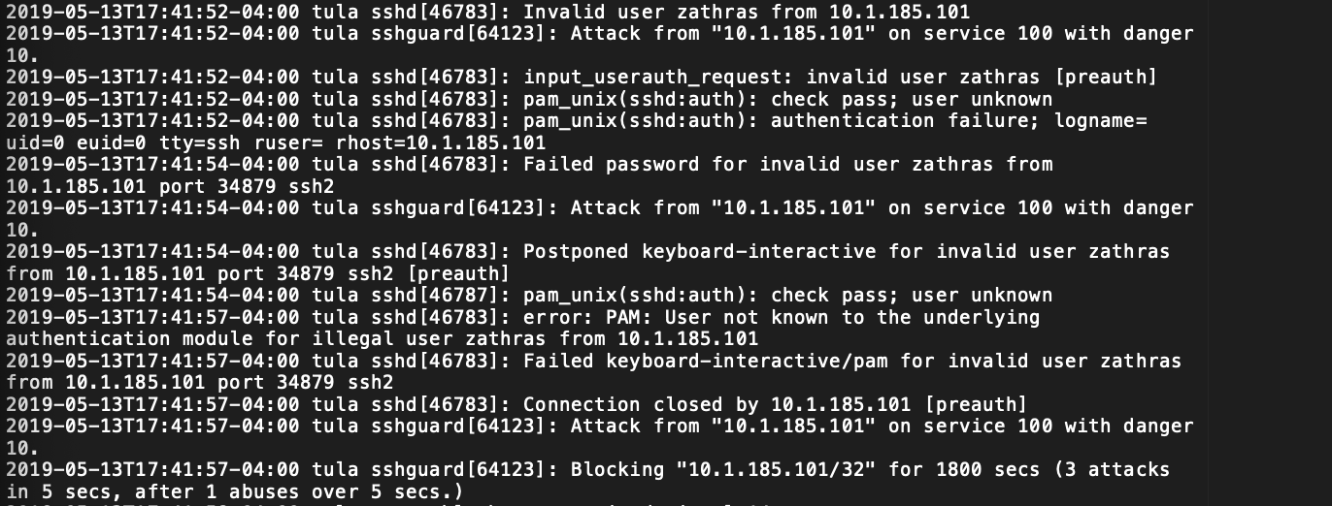

**2**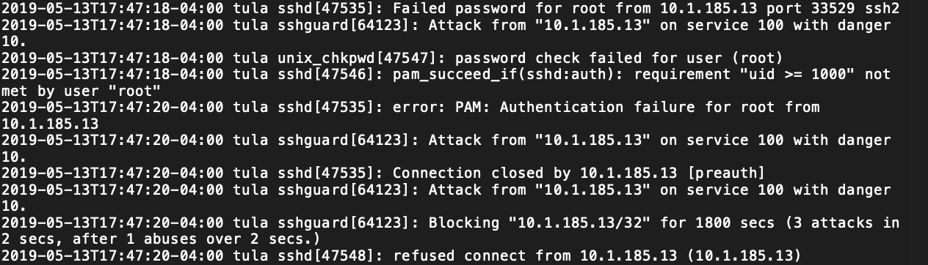

**3**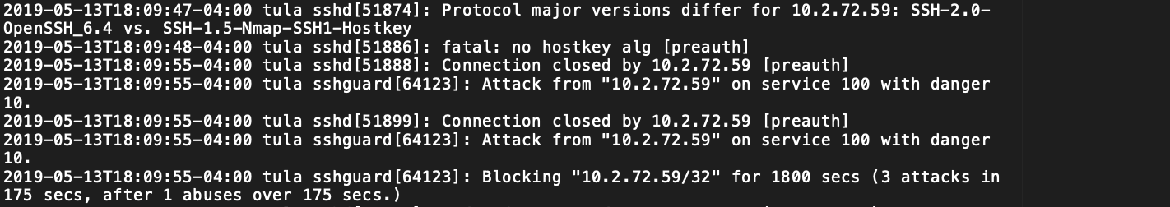

**4**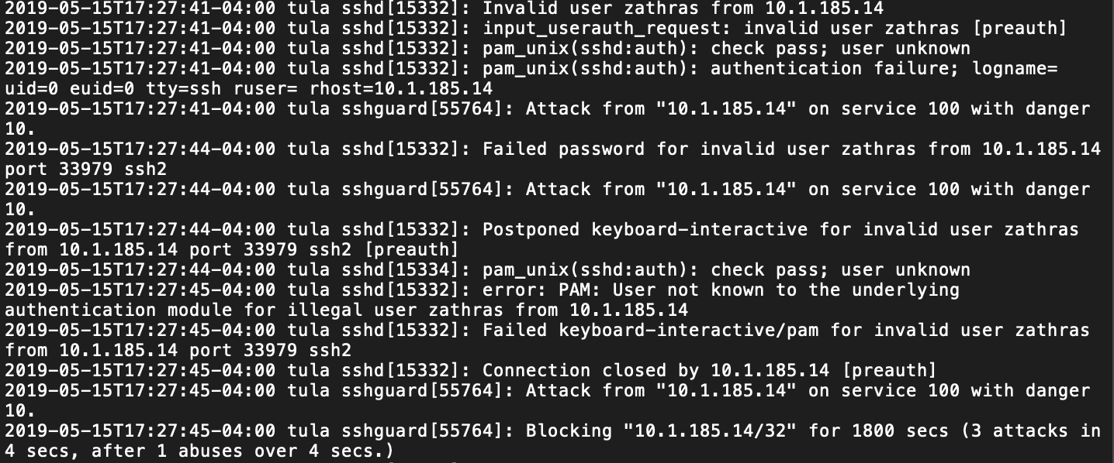

**5**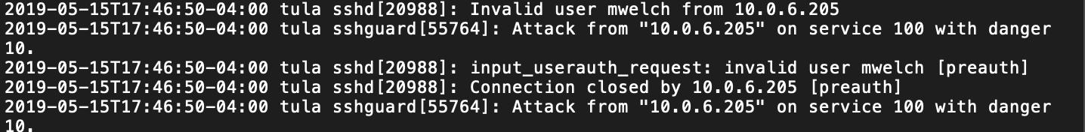

**6**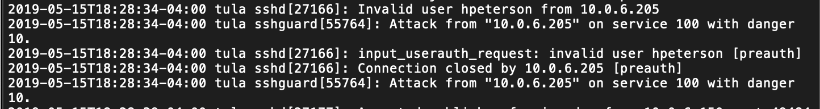

**7**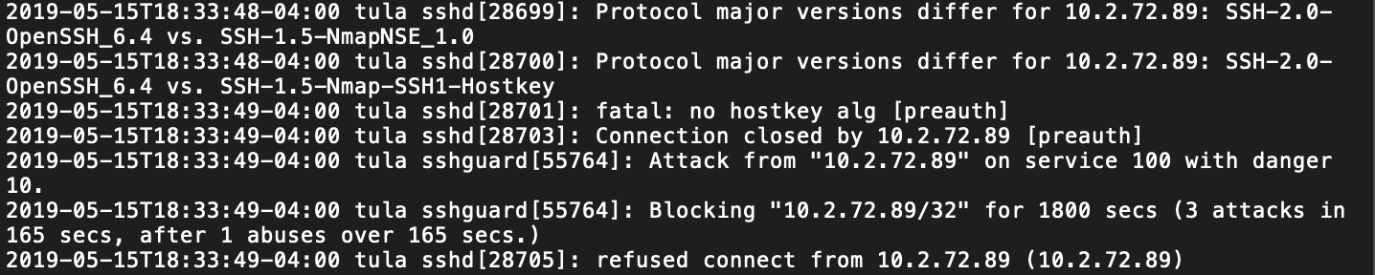

**8**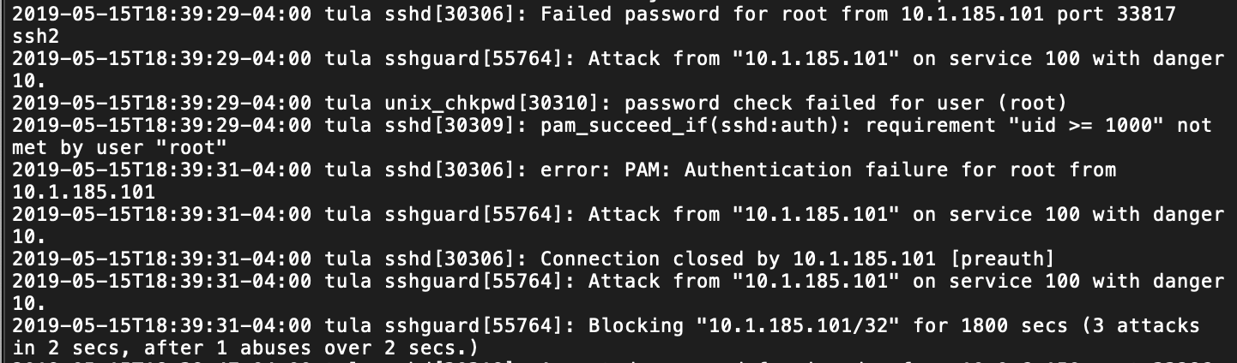

### novosibirsk

**System Builder**: Ryan Russell

**Role**: Windows Workstation

**IP Address**: 10.4.159.79

**Production**:

This was a Windows 10 machine on the Corp internal (green) network. It was required to be configured to allow psexec remote commands, and Remote Desktop access. Additionally, the Team4Account.csv file was required to be in the C:\ directory.

**Hardening**:

To harden this machine, I first changed all passwords, then removed the local Zathras user from the Admin group, followed by removing the user entirely. I then joined this machine to the corp.team4.tu domain and the domain controller sasha.corp.team4.tu. Further hardening was done through the application of group policies as detailed in the sasha machine’s Hardening section.

**System Performance During Exercise**:

This machine performed well and did not lose any services until our team received an email instructing us to run an executable on a Windows 10 machine. We ran it using an account in the Domain Users group. As a result, the responsible party was able to gain access to the Team4Account.csv file in the C:\ directory. After restarting the machine, all checks returned to normal.

**Post-Activity Log Analysis**:

A machine using the IP 10.5.222.109, presumably someone from team 5, attempted to brute force this box using SMB login. The picture below is an example of two of over a thousand failed login attempts.

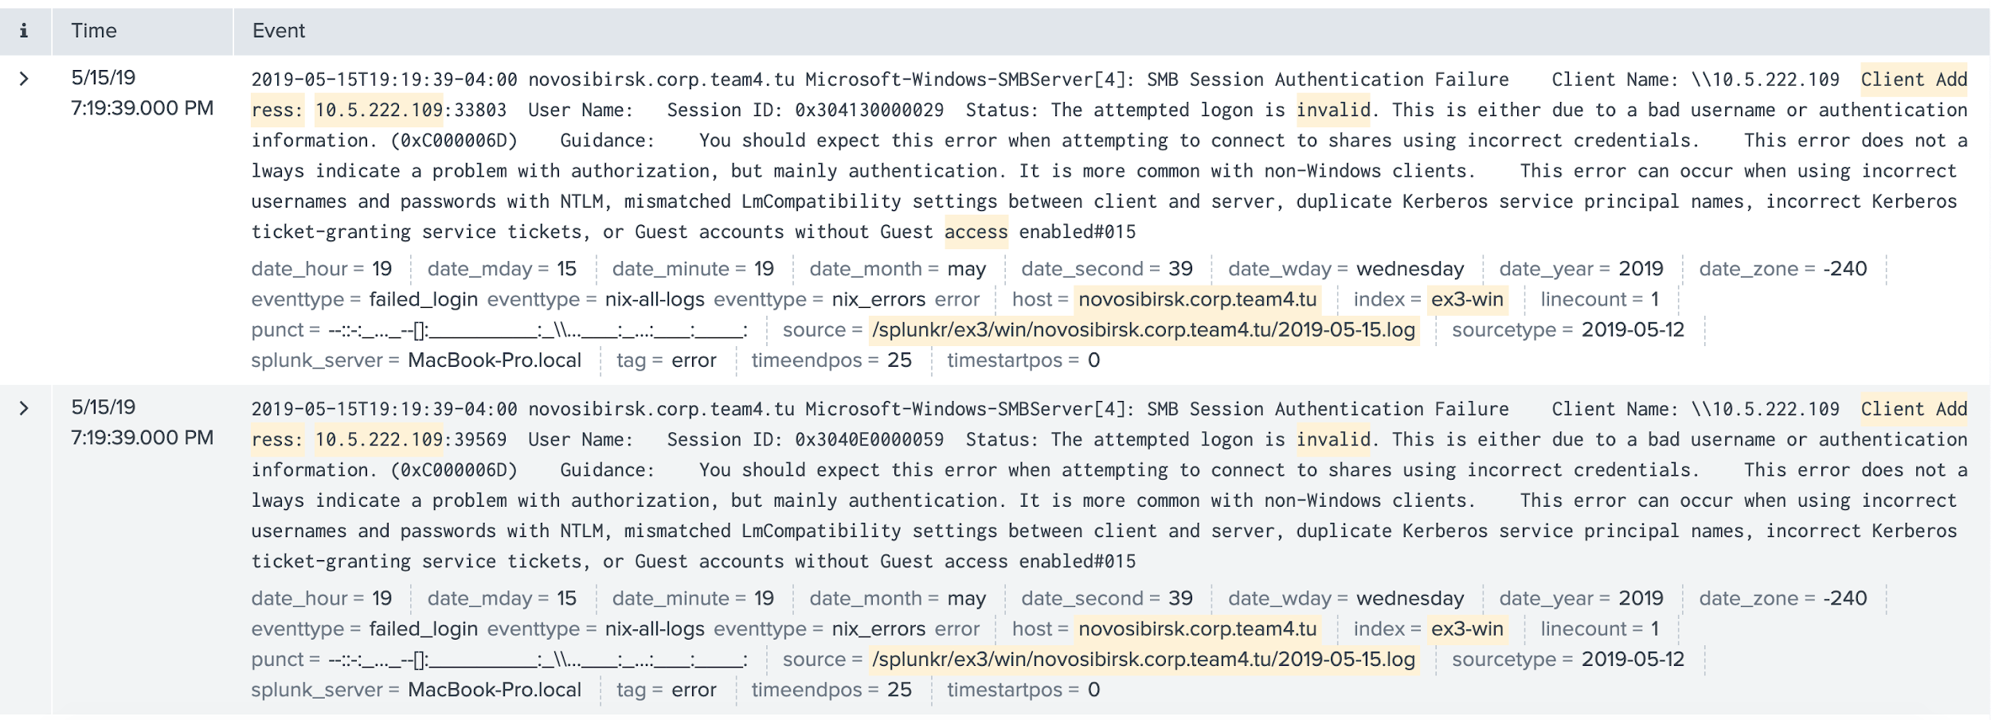

Also of note, there were many log files similar to the one shown below:

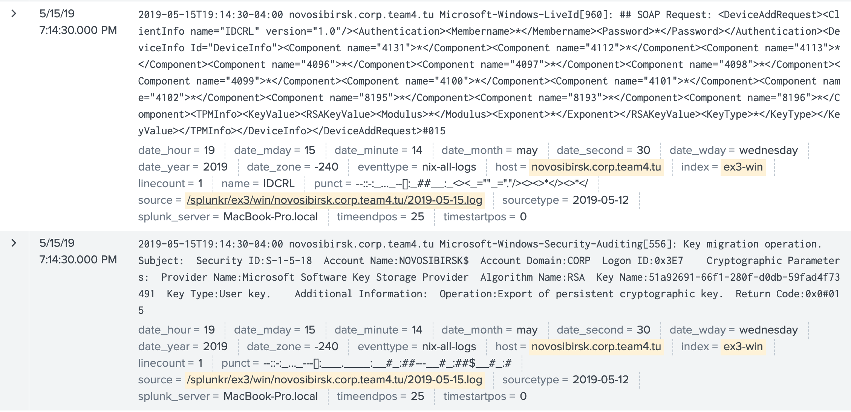

I was unable to determine what was causing these, but I don’t believe it was any service I was running.

Lastly, I believe that Exercise Control moved to the IP 10.2.72.88. As I received over a thousand RDP connections from this host without any incorrect or denied login attempts:

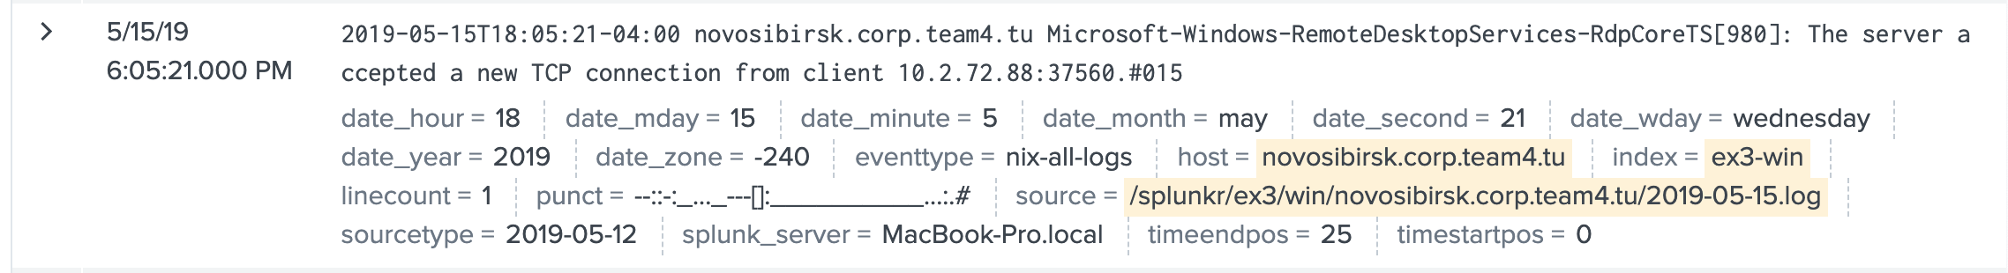

### murmansk

**System Builder**: Carleigh Duncan

**Role**: phpMyAdmin Web Server

**IP Address**: 10.4.159.68

**Production**:

This Mint 18.1 system was built as a web server on the DMZ network. The system was also set up to allow the users sbrooks and ebanks to SSH into the system. In addition, the CEO, as well as all IT and Corp staff were added to the system.

A CA cert box was configured and used to sign the required certificate that was placed in the Apache file directory.

The phpMyAdmin service was configured to access the mySQL database flag.signature on Magnitogorsk.

While FTP was correctly configured and functional, the Nagios check did not work correctly.

**Hardening**:

The default administrator ‘zathras’ was deleted and replaced with an innocuous-looking user tcruz. This user, as well as root, were each given a unique and technically-difficult password. The ability to SSH as root was disabled, and the firewall was enabled as well. SSHGuard was installed on the system and programmed to block an IP after 3 incorrect attempts.

**System Performance During Exercise**:

The system performed well and never went down.

**Post-Activity Log Analysis**:

|  |  |  |  |  |  |
| --- | --- | --- | --- | --- | --- |
| **Time** | **Offending IP/Team** | **Repeated attempts** | **Information** | **Image Number** | |
| 5/13 5:41:51 | 10.1.185.101/Team 1 |  | Attempt to SSH in as nonexistent user zathras | | 1 |
| 5/13 5:47:15 | 10.1.185.13/Team 1 |  | Attempt to SSH in as root | | 2 |
| 5/13 5:47:18 | 10.1.185.13/Team 1 |  | Attempt to SSH in as nonexistent user zathras | | 2 |
| 5/13 6:09:55 | 10.2.72.59/Team 2 |  | Nmap scan by Team 2 | | 3 |
| 5/15 5:27:36 | 10.1.185.14/Team 1 |  | Attempt to SSH in as nonexistent user zathras | | 4 |
| 5/15 5:46:44 | 10.0.6.250/Red Team | 5:51:34 | Attempt to SSH in as nonexistent user mwelch | | 5 |
| 5/15 5:53:17 | 10.0.6.250/Red Team |  | Attempt to SSH in as nonexistent user ccunnigham | | 6 |
| 5/15 6:10:38 | 10.2.72.88/Team 2 |  | Nmap scan by Team 2 | | 7 |
| 5/15 6:28:28 | 10.0.6.250/Red Team |  | Attempt to SSH in as nonexistent user hpeterson | | 8 |
| 5/15 6:33:36 | 10.2.72.89/Team 2 |  | Nmap scan by Team 2 | | 9 |
| 5/15 6:39:25 | 10.1.185.101/Team 1 |  | Attempt to SSH in as root | | 10 |
| 5/15 6:41:34 | 10.1.185.101/Team 1 | 6:41:41; 6:41:46 | Attempt to SSH in as nonexistent user zathras | | 11 |

**1**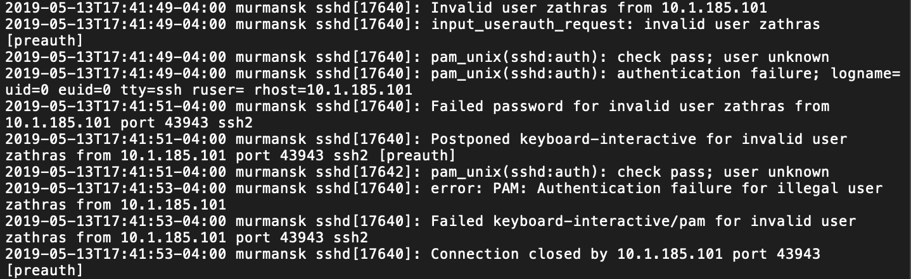

**2**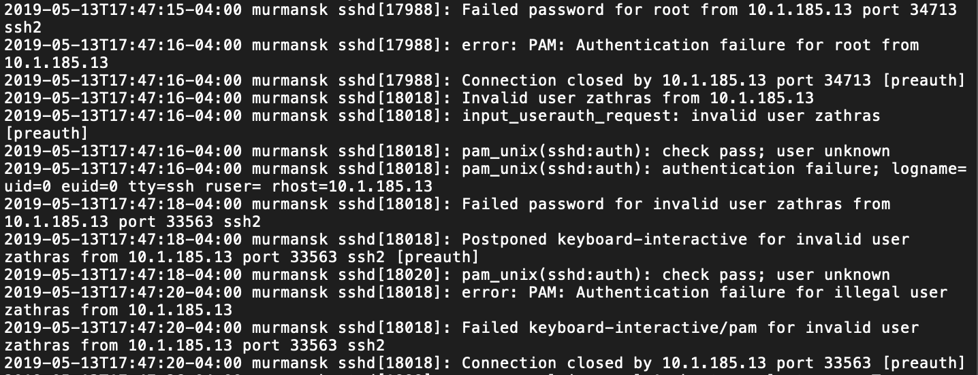

**3**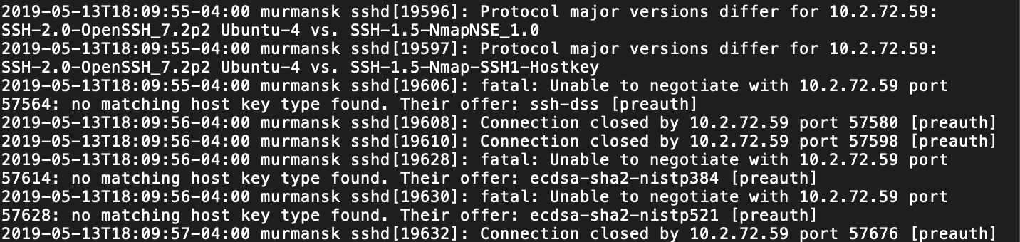

**4**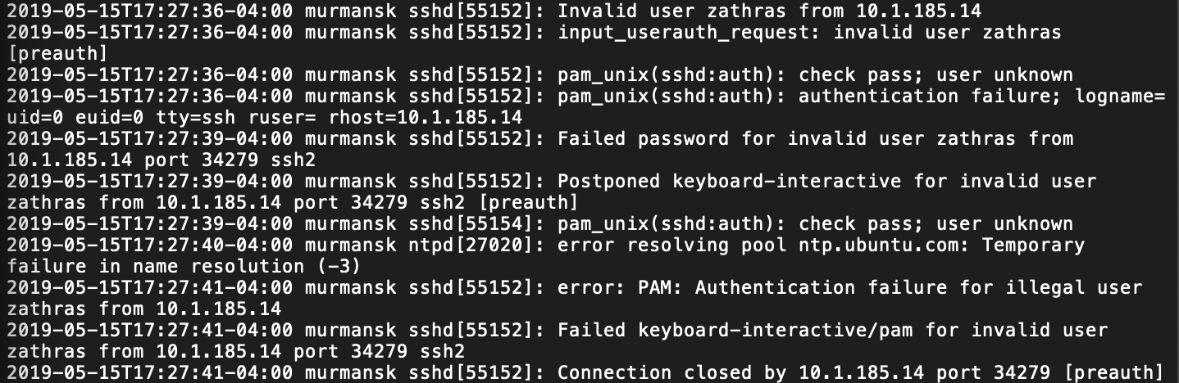

**5**

6

7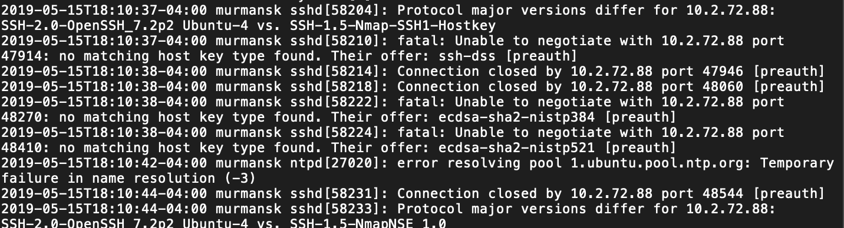

8

9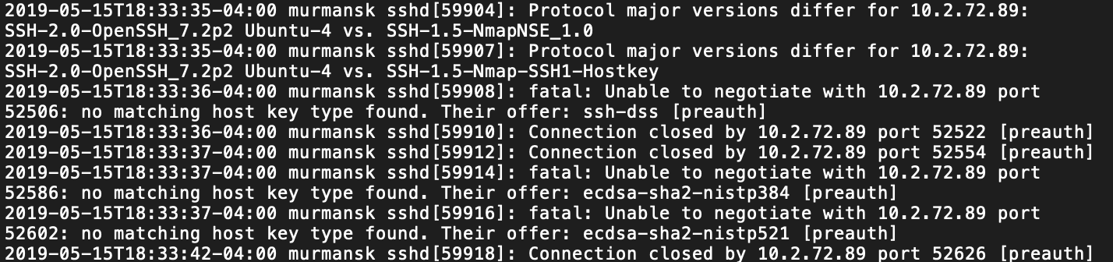

10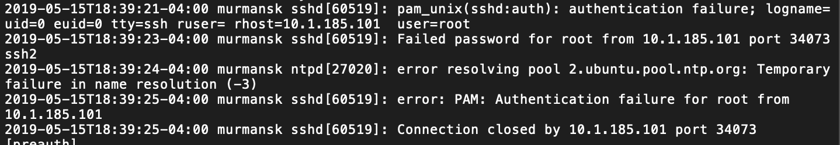

11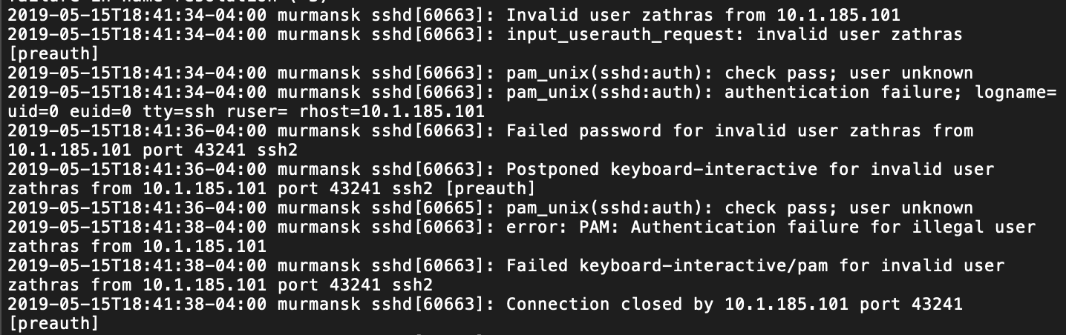

### magnitogorsk

**System Builder:**  Carleigh Duncan

**Role:** phpMyAdmin Database

**IP Address:** 10.4.159.190

**Production:**

This Ubuntu 14.04 system was built as a mySQL database on the internal network. The system was also set up to allow the users kwatkins and bjohnston to SSH into the system. In addition, the CEO, as well as all IT and Corp staff were added to the system.

A mySQL database was set up to allow user jburton access from any host to a database called flag.signature. This table had one entry in a column called ‘id’.

**Hardening:**

The default administrator ‘zathras’ was deleted and replaced with an innocuous-looking user tcruz. This user, as well as root, were each given a unique and technically-difficult password. The ability to SSH as root was disabled, and the firewall was enabled as well. SSHGuard was installed on the system and programmed to block an IP after 3 incorrect attempts.

**System Performance During Exercise:**

This system did well and did not go down.

**Post-Activity Log Analysis:**

|  |  |  |  |  |  |
| --- | --- | --- | --- | --- | --- |
| **Time** | **Offending IP/Team** | **Repeated attempts** | **Information** | **Image Number** | |
| 5/13 5:42:37 | 10.1.185.101/Team 1 |  | Attempt to SSH in as nonexistent user zathras | | 1 |
| 5/13 5:52:23 | 10.1.185.13/Team 1 |  | Attempt to SSH in as root | | 2 |
| 5/13 5:52:23 | 10.1.185.13/Team 1 | 5:52:27 | Attempt to SSH in as nonexistent user zathras | | 2 |
| 5/13 6:09:58 | 10.2.72.59/Team 2 |  | Nmap scan by Team 2 | | 3 |
| 5/15 5:27:42 | 10.1.185.14/Team 1 | 5:27:44; 5:27:54; 5:27:56 | Attempt to SSH in as nonexistent user zathras | | 4 |
| 5/15 5:27:58 | 10.1.185.14/Team 1 |  | Attempt to SSH in as root | | 5 |
| 5/15 5:46:30 | 10.0.6.205/Red Team | 5:51:24; | Attempt to SSH in as nonexistent user cwelch | | 6 |
| 5/15 5:53:06 | 10.0.6.205/Red Team |  | Attempt to SSH in as nonexistent user ccunningham | | 7 |
| 5/15 6:10:43 | 10.2.72.88/Team 2 |  | Nmap scan by Team 2 | | 8 |
| 5/15 6:27:39 | 10.0.6.205/Red Team |  | Attempt to SSH in as nonexistent user hpeterson | | 9 |
| 5/15 6:33:42 | 10.2.72.89/Team 2 |  | Nmap scan by Team 2 | | 10 |
| 5/15 6:39:36 | 10.1.185.101/Team 1 |  | Attempt to SSH in as root | | 11 |
| 5/15 6:41:48 | 10.1.85.101/Team 1 | 6:41:50; | Attempt to SSH in as nonexistent user zathras | | 12 |

1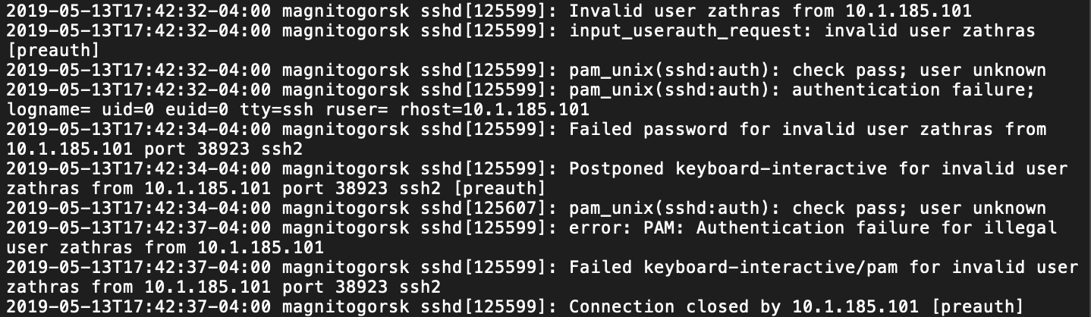

2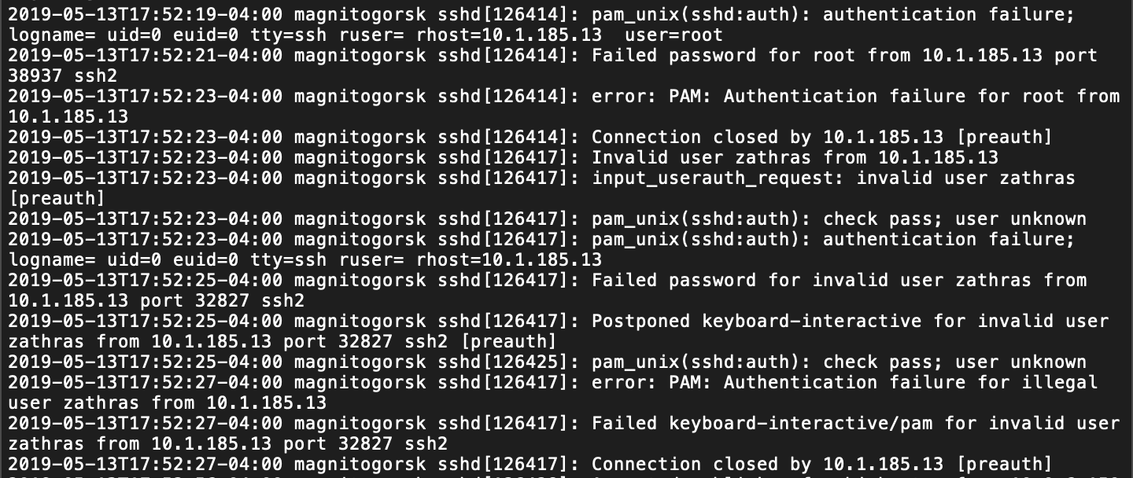

3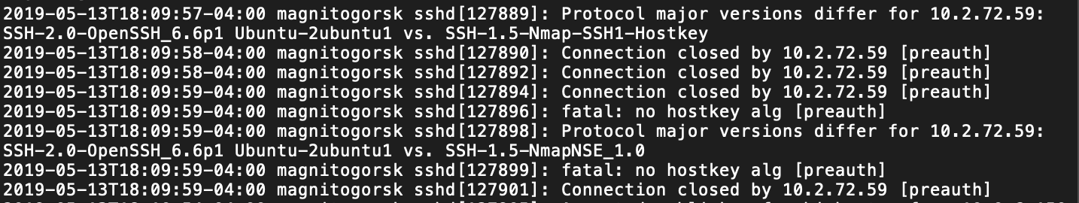

4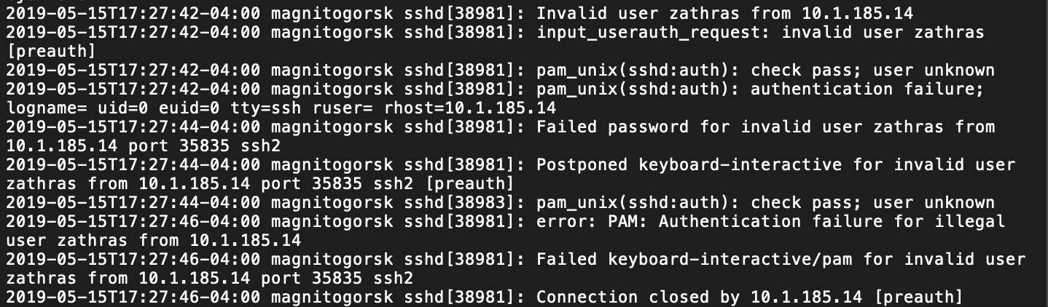

5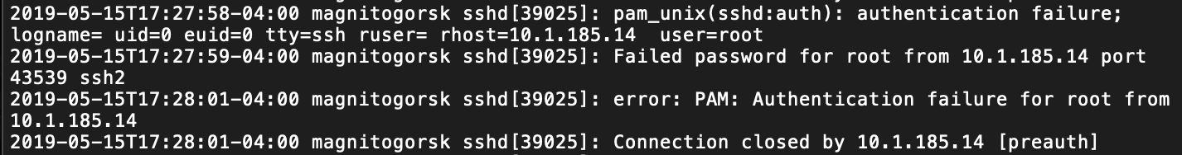

6

7

8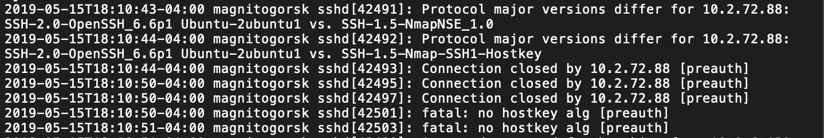

9

10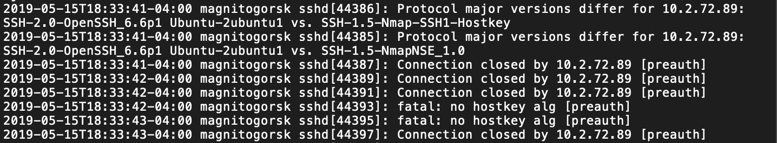

11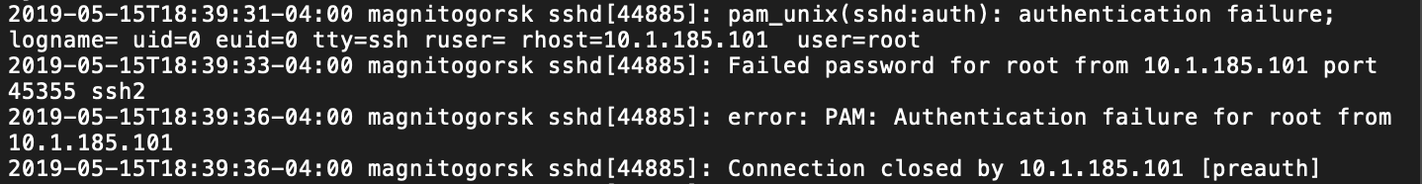

12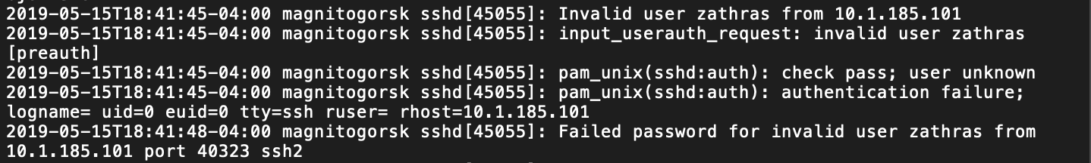

### nizhniynovgorod

**System Builder:** Ryan Russell

**Role:** Webserver & Joomla front-end

**IP Address:** 10.4.159.191

**Production:**

This was a Windows 2016 Server on the Corp DMZ (orange) network. It was required to be configured with an HTTP web page, an HTTPS web page, and a password restricted HTTPS web page, all displaying a unique string. Additionally, Joomla was installed and a Joomla web page was checked. I was never able to get the Joomla page working on this machine. This machine also required psexec authentication to complete a Nagios check. For some reason that I was not able to address, this check was constantly up and down throughout the exercise.

**Hardening:**

To harden this machine, I first changed all passwords, then removed the local Zathras user from the Admin group, followed by removing the user entirely. I then joined this machine to the corp.team4.tu domain and the domain controller niet.corp.team4.tu. Further hardening was done through the application of group policies as detailed in the sasha machine’s Hardening section.

**System Performance During Exercise:**

Other than the suspicious event noted below, the system seems to have performed without issue throughout the exercise.

**Post-Activity Log Analysis:**

Similar to Novosibirsk, there were log events that I was not able to identify, but which look suspicious:

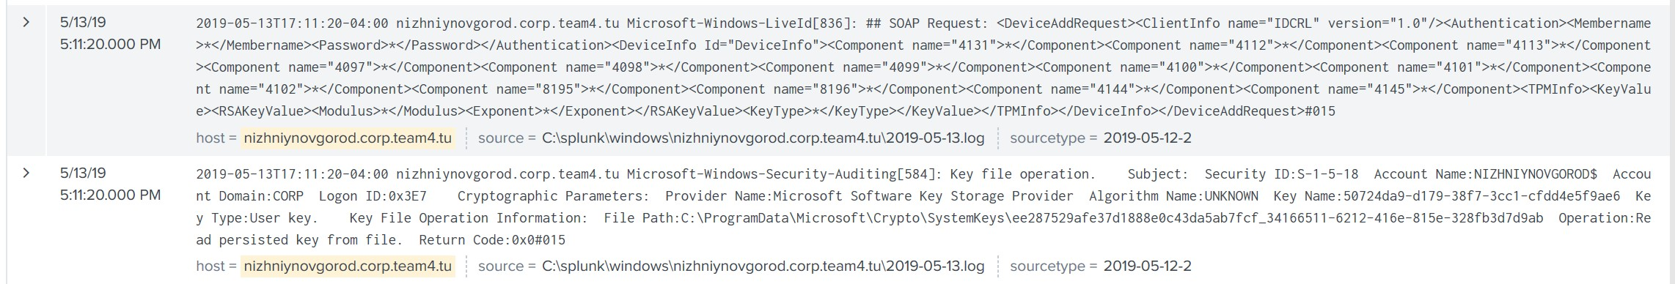

### chernobyl

**System Builder**: Carleigh Duncan

**Role**: Workstation

**IP Address**: 10.4.159.12

**Production**:

This Windows Server 2012 was built with the sole purpose of checking emails and running applicable malware. Its external IP address was added to the DMZ DNS tver.

**Hardening**:

SMB1 was disabled on this machine. The administrator ‘zathras’ was deleted, and the new administrator, tcruz, was given a unique and technically difficult password. The firewall was confirmed to be on as well.

**System Performance During Exercise**:

During the exercise, littlebottom@classex.tu (which is team 2) sent an email containing a file test.bat and requested it be run on a Windows Server 2012. It was run and the system rebooted. I did not sign in again for the remainder of the exercise, assuming it was a keylogger.

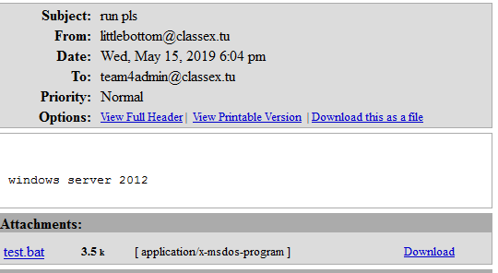

**Post-Activity Analysis:**

After the exercise, I logged into this system to be greeted with the following prompt.

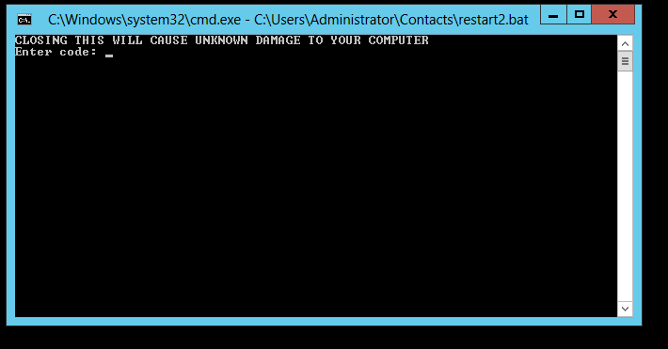

As it turns out, team 2 sent a ransomware. Exiting the prompt caused the screen to go black and be unresponsive. This likely overwrote the bootloader or deleted the system32 folder.

### Ukraine

**System Builder**: Carleigh Duncan

**Role**: Workstation

**IP Address**: 10.4.159.14

**Production**:

This Windows 10 machine was built with the sole purpose of checking emails and running applicable malware. Its external IP address was added to the DMZ DNS tver.

**Hardening**:

SMB1 was disabled on this machine. The administrator ‘zathras’ was deleted, and the new administrator, tcruz, was given a unique and technically difficult password. The firewall was confirmed to be on as well.

**System Performance During Exercise**:

Two malware were run on this system. One was sent by dorfl@classex.tu, which is team 5, and the other was sent by fred@classex.tu, which I believe to be team 3.

Lol.exe was blocked by Windows Defender, and notmalware.bat just exited the system. 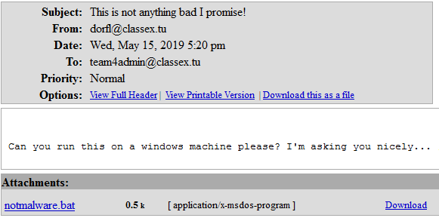

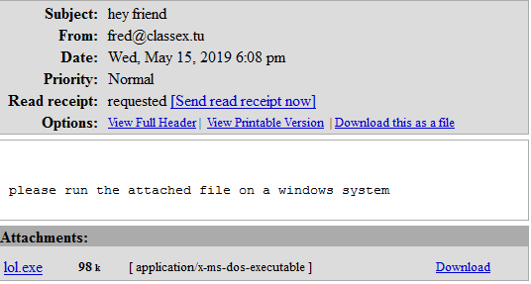

### Kiev

**System Builder**: Carleigh Duncan

**Role**: Workstation

**IP Address**: 10.4.159.15

**Production**:

This Ubuntu 16.04 system was built with the sole purpose of checking emails and running applicable malware. Its external IP address was added to the DMZ DNS tver.

**Hardening**:

The administrator ‘zathras’ was deleted, and the new administrator, tcruz, was given a unique and technically difficult password. The firewall was confirmed to be on as well. The ability to SSH to root was also disabled.

**System Performance During Exercise**:

Two malware were opened on this system, and both of which resulted in an error. The logs showed that they did nothing to the system.

The two teams responsible for these malware were team 1 and team 3, although I am not sure which one is which. (I believe fred.classex.tu is team 3 and reg.classex.tu is team 1).

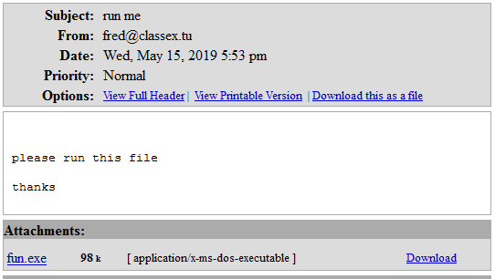

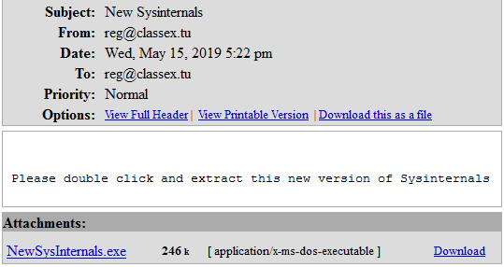

### Reactorone

**System Builder**: Carleigh Duncan

**Role**: Workstation

**IP Address**: 10.4.159.16

**Production**:

This Mint 18 system was built with the sole purpose of checking emails and running applicable malware. Its external IP address was added to the DMZ DNS tver.

**Hardening**:

The administrator ‘zathras’ was deleted, and the new administrator, tcruz, was given a unique and technically difficult password. The firewall was confirmed to be on as well. The ability to SSH to root was also disabled.

**System Performance During Exercise**:

Nothing of interest occurred on this system.

### basegi

**System Builder**: Carleigh Duncan

**Role**: Snort

**IP Address**: 10.4.159.30

**Production**:

This Ubuntu 14.04 system was originally made to run the IDS SNORT; however, the idea ended up being abandoned before the exercise. The system remained on the network.

**Hardening**:

The system administrator ‘zathras’ was deleted and the system administrator mfreeman was the added to the system. The firewall was activated and the ability to SSH to root was disabled.

**System Performance During Exercise**:

On day one, an email was sent by dorfl.classex.tu (which is team 5) with the attachment runmeonlinux.exe, as shown below.

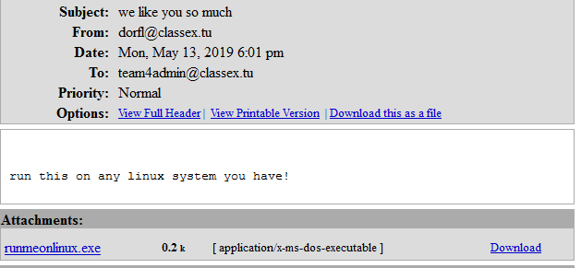

After running this attachment on the system, an error occurred as shown below.

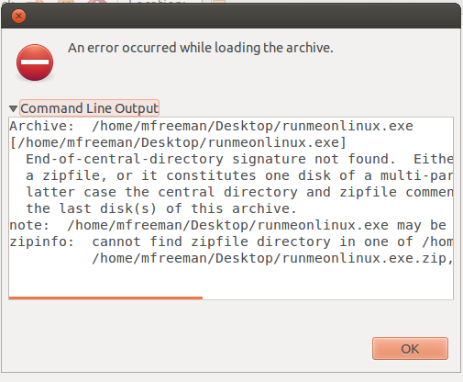

Nothing was noted in the logs.

### Bear

**System Builder:** Ryan Russell

**Role:** IPFire admin interface

**IP Address:** 10.4.159.34

**Production:**

This was a CentOS 7 Server on the Corp internal (green) network. It’s sole purpose was to access the IPFire Administration Web GUI without any outside connection. To that end, the external (red) IP address shown above was not given any firewall rules to allow connections through directly to this machine.

**Hardening:**

To harden this machine, I immediately changed the passwords for the Zathras and root users, followed by creating another user in the wheel group (giving sudo permission), and concluding with the deletion of the Zathras user. I then installed Fail2Ban, and configured it for SSH protection. While important, this turned out to be redundant, as I disabled everything but web traffic on TCP 80 and 443 on this machine.

Additionally, I configured Firefox to use the IP address and port I configured on the IPFire box to allow web traffic through, including the Admin interface and the connection to monitor Exercise Control.

**System Performance During Exercise:**

This system was untouched during the exercise, as it was intended.

**Post-Activity Log Analysis:**

There were no logs of any interest on this machine.

## Sales

### adrik

**System Builder:** Curtis Smallwood

**Role:** DNS

**IP Address:** 10.4.176.29

**Production:**

Hardening: Through Powershell SMBv1 was disabled and verified. A user lockout policy was set to block them after 3 failed attempts for 75 minutes through Group Policy. Most firewall rules were set to block traffic since this machine was not checked by Nagios and sole purpose was to serve DNS.

**System Performance During Exercise:**

This machine stayed up the entire time and was not accessed by any other teams including red team. In IpFire, a rule was set to allow inbound UDP and TCP traffic on port 53 only. Otherwise all other traffic was blocked so there was not many exploits another team could try.

**Post-Activity Log Analysis:**

There were no logs that displayed any failed login attempts or unauthorized access to this machine for both days.

### krasnoyarsk

**System Builder:** Brittany Galata

**Role:** External Bind DNS

**IP Address:** 10.4.176.53

**Production:**

This Ubuntu 16.04 system was built as the DMZ Bind DNS. All the IP addresses used in this DNS were the external IP addresses. The system was also set up to allow the users areid, sturner, and dhunt to SSH into the system. The Team4Account.csv was also hosted on this system in the root (“/”) directory.

**Hardening:**

Fail2ban was installed on the system which would block an ip after 5 unsuccessful SSH logins to protect against brute force attacks. The ability to SSH to root was also disabled. All user passwords were changed for the first and second day of the exercise. Passwords for the root and administrator user “zathras” was changed to a unique password.

**System Performance During Exercise:**

The system performed well. There were no services that went down during the exercise.

**Post-Activity Log Analysis:**

Multiple unsuccessful root login attempts made by 10.1.185.101 and 10.1.185.13 on the first and second day of the exercise.

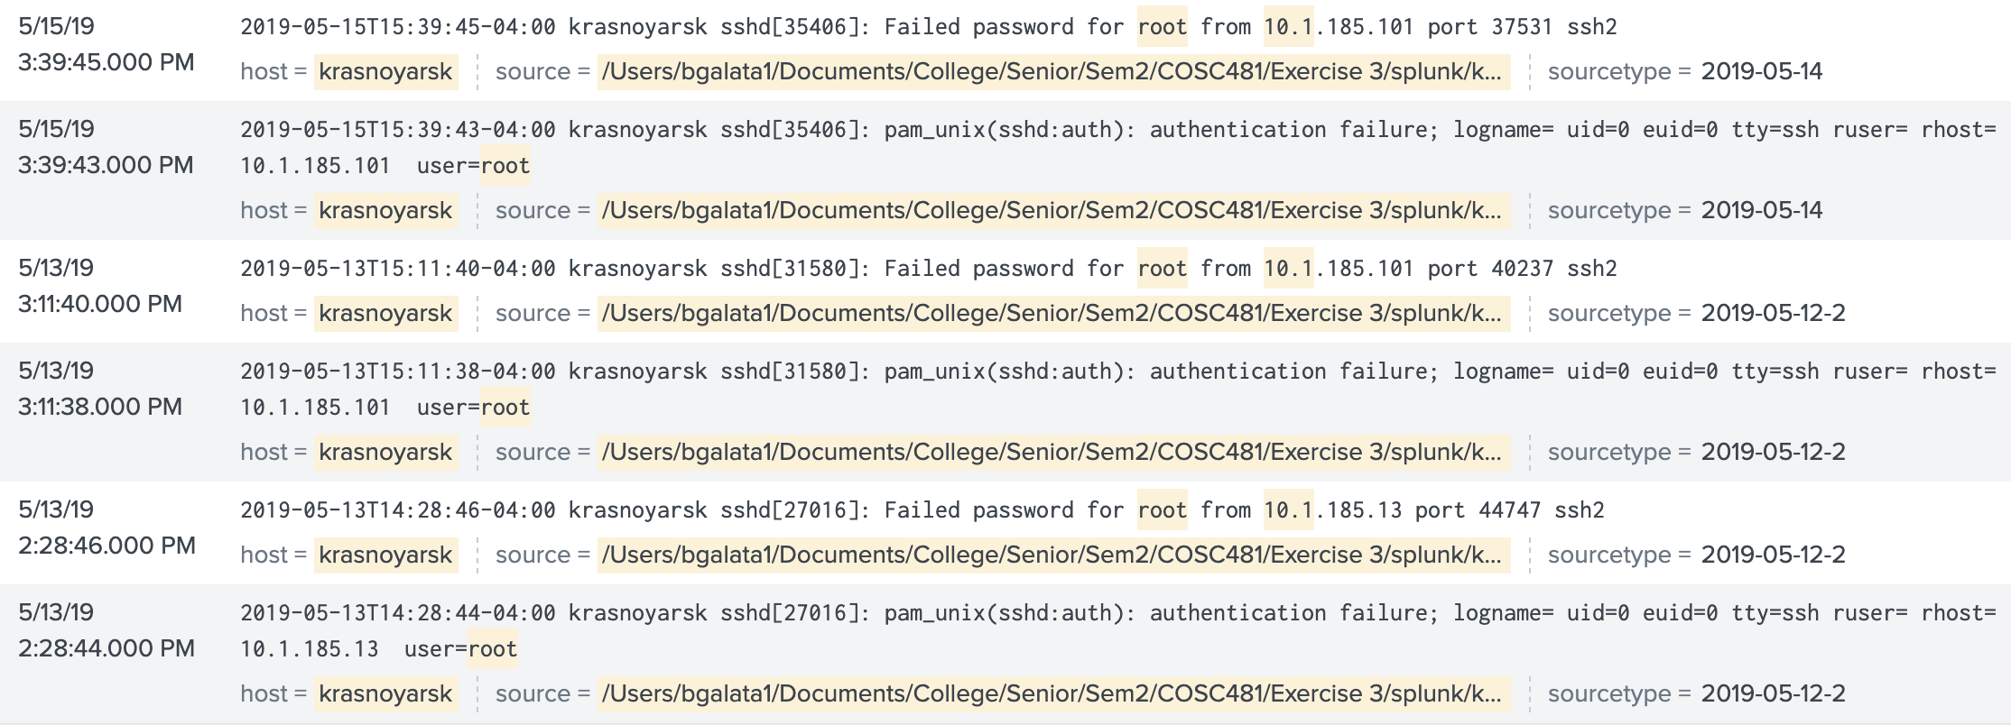

Multiple unsuccessful zathras login attempts made by 10.1.185.101, 10.1.185.13, and 10.1.185.14 on the first and second day of the exercise.

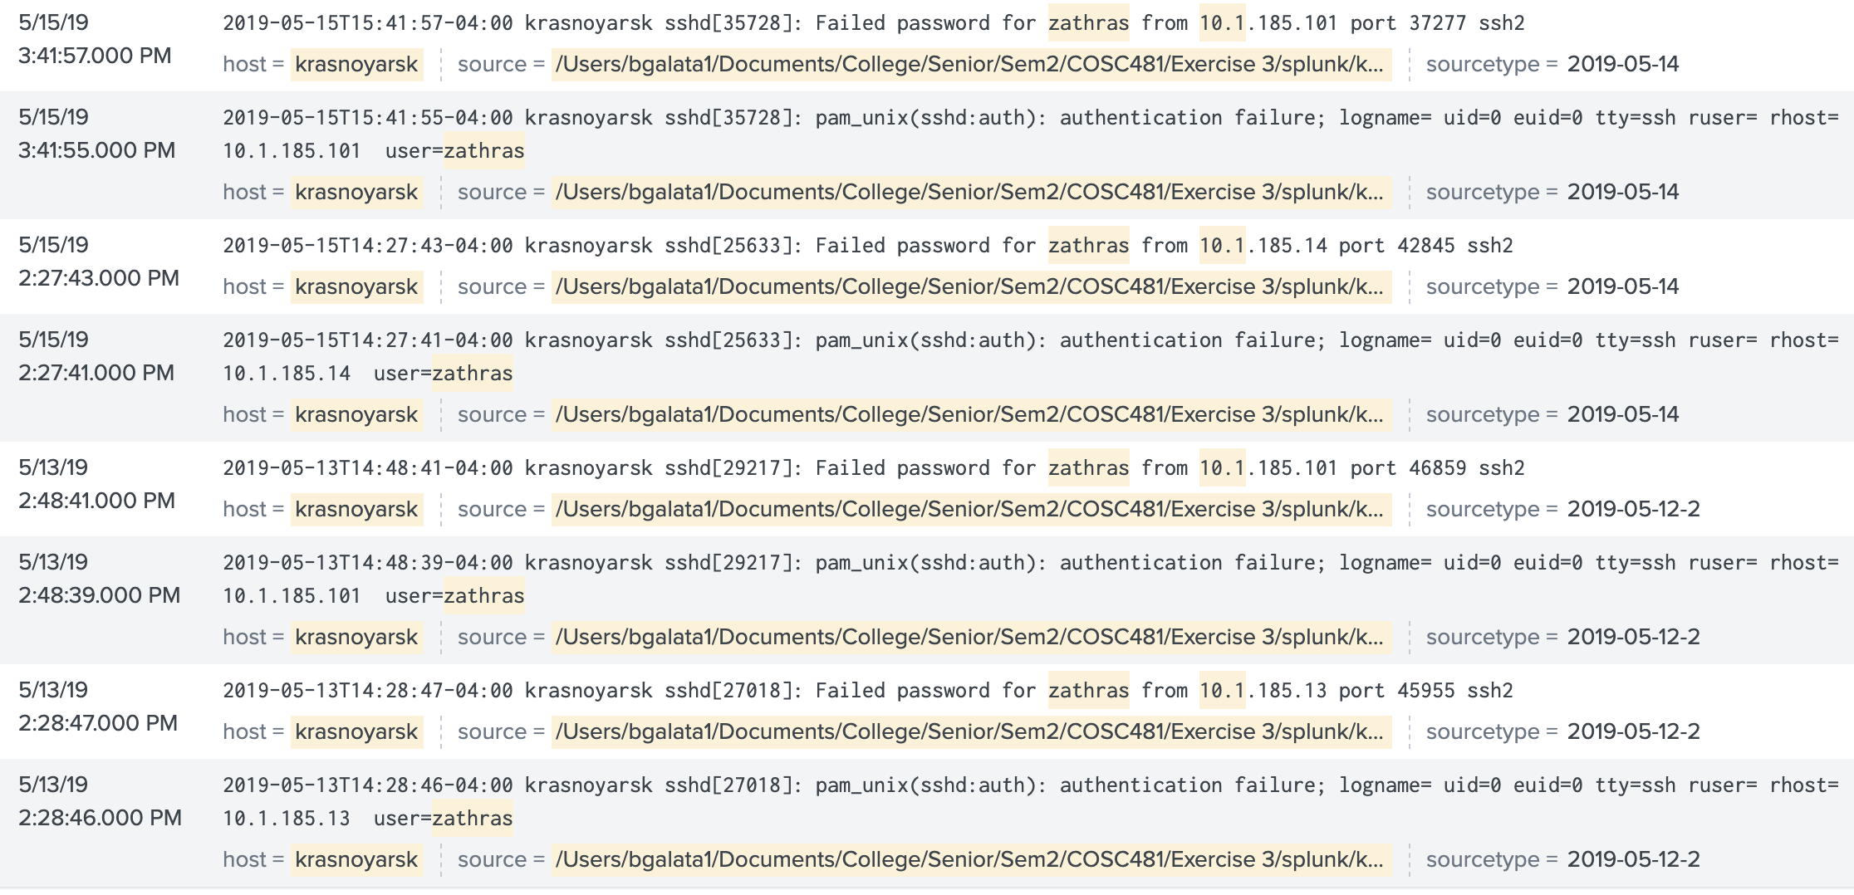

Multiple unsuccessful user login attempts made by 10.0.6.205 on the second day of the exercise.

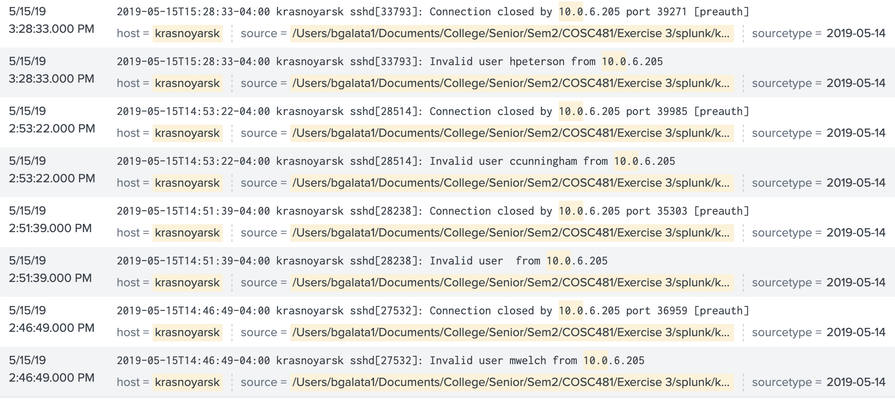

Unsuccessful brute force attack against user sbrooks by IP address 10.5.222.109 on the second day of the exercise.

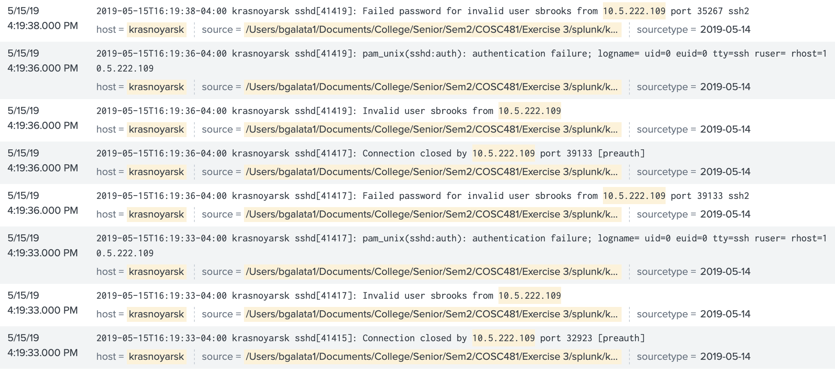

### bakal

**System Builder:** Brittany Galata

**Role:** Internal Bind DNS

**IP Address:** 10.4.176.183

**Production:**

This Ubuntu 14.04 system was configured as an Internal Bind DNS. The IP addresses used in this DNS were all internal IP addresses.

**Hardening:**

Fail2ban was installed on the system which would block an ip after 5 unsuccessful SSH logins to protect against brute force attacks. The ability to SSH to root was also disabled. Passwords for the root and administrator user “zathras” was changed to a unique password.

**System Performance During Exercise:**

This system was not being checked by Nagios, but the system did well and didn’t go down at any time.

**Post-Activity Log Analysis:**

There weren’t any notable log entries against bakal.

### vladimir

**System Builder:** Brittany Galata

**Role:** Linux Workstation

**IP Address:** 10.4.176.175

**Production:**

This Mint 17.01 system was built as the linux workstation on the sales network. The system was set up to allow the users jlewis, george, and bfisher to SSH into the system. FTP was also installed on the system. The Team4Financial.csv was also hosted on this system in the root (“/”) directory.

**Hardening:**

Fail2ban was installed on the system which would block an ip after 5 unsuccessful SSH logins to protect against brute force attacks. The ability to SSH to root was also disabled. All user passwords were changed for the first and second day of the exercise. Passwords for the root and administrator user “zathras” was changed to a unique password.

**System Performance During Exercise:**

The system performed well. There were no services that went down during the exercise. The only service that was down since setup was FTP, but this is likely due to unidentified IPFire rule as FTP was installed and working correctly.

**Post-Activity Log Analysis:**

Multiple unsuccessful root login attempts made by 10.1.185.101 and 10.1.185.13 on the first and second day of the exercise.

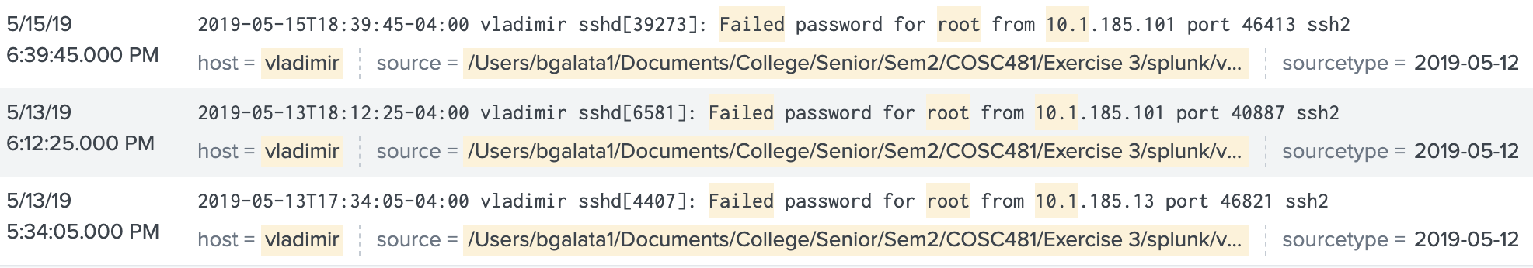

Multiple unsuccessful zathras login attempts made by 10.1.185.101, 10.1.185.13, and 10.1.185.14 on the first and second day of the exercise.

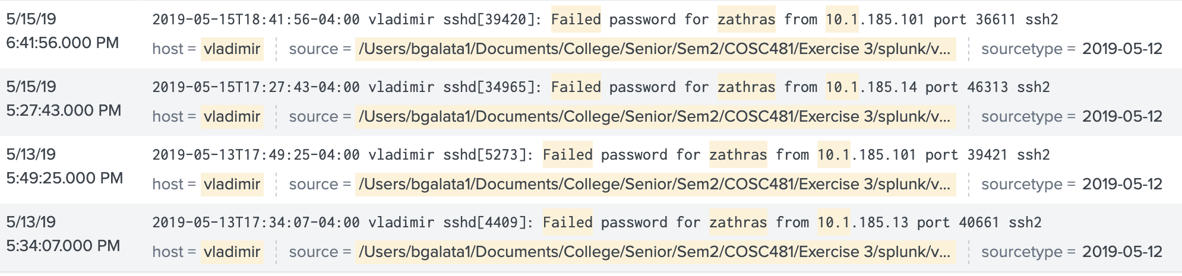

Multiple unsuccessful user login attempts made by 10.0.6.205 on the second day of the exercise.

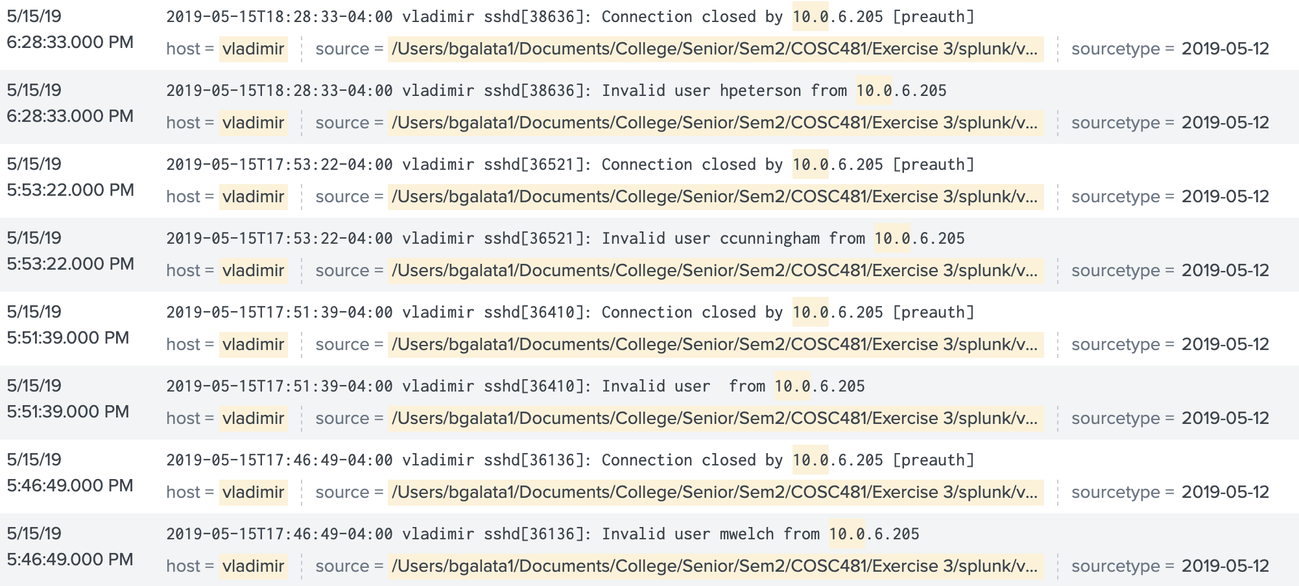

### magadan

**System Builder:** Jacob Kokai-Kun

**Role:** Windows IIS & phpMyAdmin

**IP Address:** 10.4.176.196

**Production:**

Magadan was produced on a windows server 2012 R2 vm, it was made to run IIS for http and https web pages, and was accessible from the dmz of Putinka. In addition it would connect to the remote database on Saratov for use with phpMyAdmin.

**Hardening:**

To reduce the amount of possible attacks the first step was to delete zathras and give the administrator a more secure password then the default “password1!” thus eliminating the two easiest ways for an attacker to gain access. The next step was to set the account lockout threshold for the sales domain controller which after 5 unsuccessful login attempts as a user would lock the account, preventing any brute force attempts. Finally smb was disabled using PowerShell using the command “Disable-WindowsOptionalFeature -Online -FeatureName smb1protocol” to defend against the eternal blue exploit for windows.

**System Performance During Exercise:**

During the exercise on day one Magadan and it’s services remained up the entire time and there was no sign of any attacks being launched against it or any breach in security. The same was true of the second day Magadan remained up, however one service for the password protected https page went down. The reason was an attempted brute force attack trying to login as jwatkins caused the account to get locked (due to the lockout policy) which meant the user couldn’t authenticate to the password protected page. However, this was only for a short while, shortly after jwatkins password was changed and the account was unlocked causing the service to come back up.

**Post-Activity Log Analysis:**

(note not every brute force attempt in the logs will be listed as they are all the same error from the same remote ip)

|  |  |  |  |  |  |
| --- | --- | --- | --- | --- | --- |
| **Time** | **Offending IP/Team** | **Repeated attempts** | **Information** | **Image Number** | |
| 5:18 to 6:12 day 2 | 10.5.222.109/Team 5 | 250 ~ 300 | SMB Session Authentication Failure | | 1 |
| 5:18 to 6:12 day 2 | 10.5.222.109/Team 5 | 250 ~ 300 | The server denied anonymous access to the client | | 1 |
| 5:18 to 6:12 day 2 | 10.5.222.109/Team 5 | 250 ~ 300 | An account failed to log on: | | 1 |

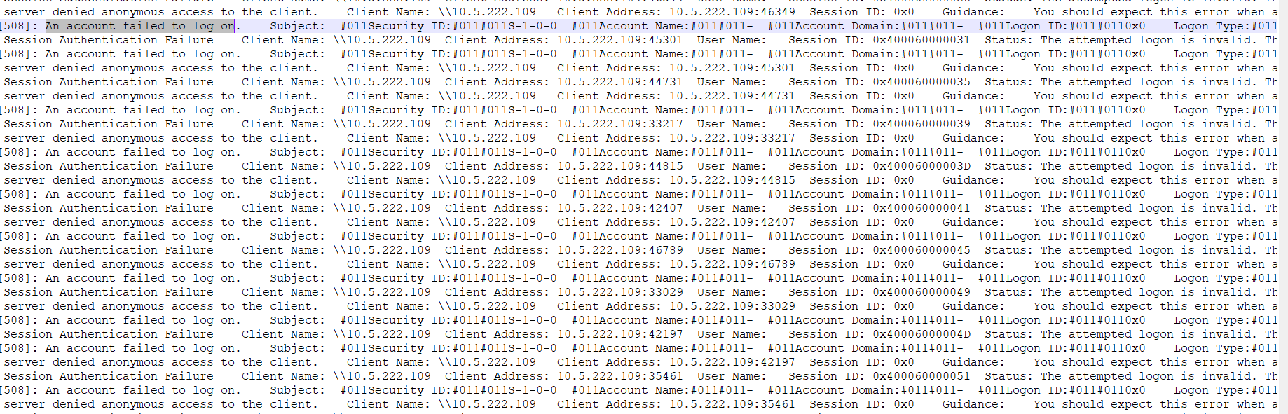

This brute force attack by team 5 on day 2 was unsuccessful, it finally ended at 6:12 when the attacking team realized they were just wasting their time and canceled the attack. Looking through the logs the team was trying every user they knew existed on our network however many of those users did not exist on this local machine and as such they were not able to gain entry. Even if they did find a user that did exist the account would be locked out after 5 tries meaning that team 5 wouldn't be able to get in anyways.

### saratov

**System Builder:** Jacob Kokai-Kun

**Role:** MySQL database for magadan, psexec & winrm

**IP Address:** 10.4.176.160

**Production:**

Saratov was built on a windows 2008 R2 distro, the purpose of saratov was to act as a remote database for magadans phpMyAdmin service. This box was placed on the internal network, the idea being since it’s only purpose is to provide a database that only magadan would need access to it could be placed on the internal network and rules could be created so that only magadan would be able to connect to it aside from pings.

**Hardening:**

Like most of the windows machines on our network the user zathras was deleted and the administrator password was changed to a randomly generated 16 digit string of numbers and letters to eliminate any easy access to the machine. In addition smb was disable to ensure protection against the eternal blue exploit, and account lockout threshold was set to lock an account for an hour after 5 unsuccessful logins.

**System Performance During Exercise:**

During the exercise Saratov and all of its services were up for the duration of days 1 and 2.

**Post-Activity Log Analysis:**

|  |  |  |  |  |  |
| --- | --- | --- | --- | --- | --- |
| **Time** | **Offending IP/Team** | **Repeated attempts** | **Information** | **Image Number** | |
| 5:15 to 5:32 day 2 | 10.5.222.109/Team 5 | 46 | An account failed to logon | | 1 |

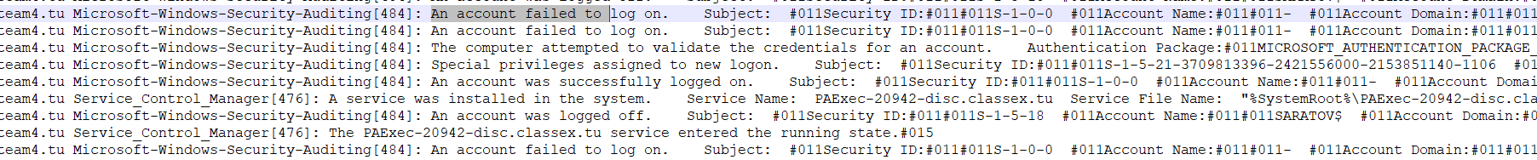

Like with magadan the same team 5 address tried multiple times to login remotely to saratov however they were attempting with users that did not exist on the machine. Once they realised this they stopped their attack on day 2 at 5:32

### chita

**System Builder:** Curtis Smallwood

**Role:** Wordpress front end

**IP Address:** 10.4.176.141

**Production:** This machine was running CentOS 7 with Wordpress 4.0 installed on it. It had the Wordpress database located on another machine in the Internal network that was running MariaDB 5.5 on Centos 6.5.

**Hardening:**

SSHGuard was installed and running throughout the entire exercise. Firewall rules were set to only allow inbound HTTP, HTTPS and SSH traffic to this machine. Curtis wrote a script that made MD5 hashes of each user’s authorized_keys file to ensure nobody replaced a user’s key with their own. That same script also created hashes of the **/etc/passwd**, **/etc/shadow,** and **/etc/groups** files. This was done to verify the authenticity of all users and their passwords both during and after the exercises. See the script below (image 1). Another script was used to cycle through all users and check the presence of any cron jobs that could have been used to constantly disable services or provide a shell for another team. This script was run constantly throughout the exercise and never found any cron jobs for any users. See script below (image 2). Additionally, the root password was changed and the Zathras user was deleted completely from the system.

**System Performance During Exercise:**

This machine stayed up the entire exercise and never had any checks go down. Thanks to SSHGuard running, nobody was able to login to this machine unless they knew the password for a user.

**Post-Activity Log Analysis:**

Team 1 attempted to login as the deleted user “Zathras” and as root a few time. This was the only indication of red team activity on this machine for Day 1. On Day 2, a machine with the IP of 10.4.116.22 attempted to brute force a login with the user “sbrooks” but they failed thanks to SSHGuard. Below is a snippet of the logs indicating the brute force attack (day 2 photo).  
Day 1:  
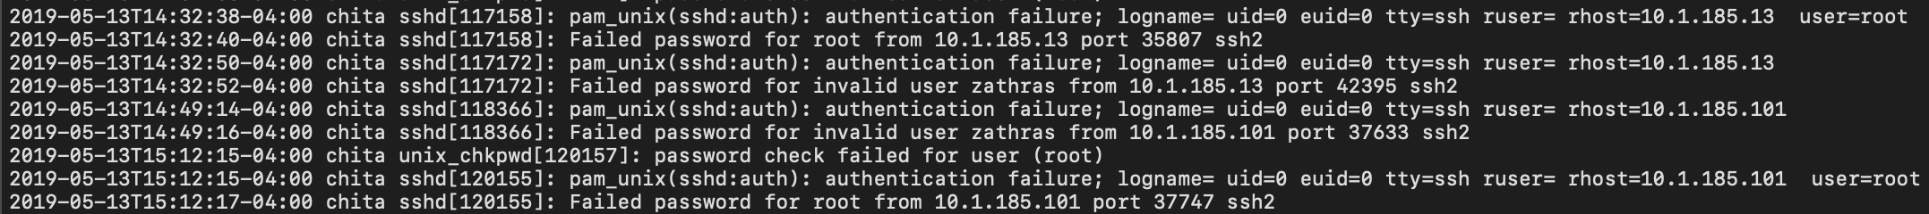

Day 2:  


### stpetersburg

**System Builder:** Curtis Smallwood

**Role:** MariaDB Database for a Wordpress site

**IP Address:** 10.4.176.12

**Production:**

This machine was running MariaDB 5.5 on CentOS 6.5 and was responsible for running the backend database for a Wordpress website that was located in the DMZ network. This database was also responsible for having a database named “flag” with a table named “signature” that had a single record specified by the instructions for this exercise.

**Hardening:**

SSHGuard was installed and running throughout the entire exercise. Firewall rules were set to only allow inbound MySQL and SSH traffic to this machine on ports 3306 and 22. Curtis wrote a script that made MD5 hashes of each user’s authorized_keys file to ensure nobody replaced a user’s key with their own. That same script also created hashes of the **/etc/passwd**, **/etc/shadow,** and **/etc/groups** files. This was done to verify the authenticity of all users and their passwords both during and after the exercises. See the script below (image 1). Another script was used to cycle through all users and check the presence of any cron jobs that could have been used to constantly disable services or provide a shell for another team. This script was run constantly throughout the exercise and never found any cron jobs for any users. See script below (image 2). Additionally, the root password was changed and the Zathras user was deleted completely from the system.

**System Performance During Exercise:**

This machine stayed up the entire exercise and never had any checks go down. Thanks to SSHGuard running, nobody was able to login to this machine unless they knew the password for a user. No users logged in via MySQL during this exercise despite the MySQL user being allowed in from any 10.x.x.x address.

**Post-Activity Log Analysis:**

Team 1 attempted to login as the deleted user “Zathras” and as root a few time. This was the only indication of red team activity on this machine for both days.  
Day 1: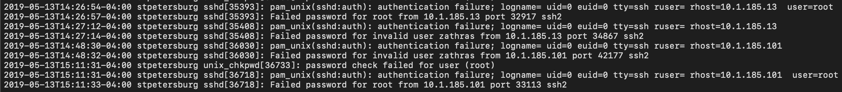  
Day 2:  


### samara

**System Builder:** Brittany Galata

**Role:** Log Monitor

**IP Address:** 10.4.176.122

**Production:**

This Mint 18.1 system was built as the team's main log monitor. All logs were forwarded to the samara log monitor. In “/etc” the “rsyslog.conf” file was edited to have the logs sent to their own files by machine and time in the “/var/log/remote_hosts” directory. The system was also set up to allow the users canderson and areid to SSH into the system.

**Hardening:**

Fail2ban was installed on the system which would block an ip after 5 unsuccessful SSH logins to protect against brute force attacks. The ability to SSH to root was not disabled, since teammates needed to monitor their logs via SSH and multitail. All user passwords were changed for the first and second day of the exercise. Passwords for the root and administrator user “zathras” was changed to a unique password.

**System Performance During Exercise:**

The system performed well. There were no services that went down during the exercise.

**Post-Activity Log Analysis:**

There weren’t any notable log entries against samara.

## Cloud

### novgorod

**System Builder:** Curtis Smallwood

**Role:** DNS and Psexec for the Cloud network

**IP Address:** 10.4.161.93

**Production:**

This was a GUI-less Windows Server 2016 that was responsible for running DNS for the Internal Cloud network.

**Hardening:**

Windows firewall rules were disabled for any “File and Printer Sharing” on this machine since no Nagios checks were requesting SMB services. An account lockout rule was set through Group Policy to lockout any users after 3 failed login attempts for 75 minutes. SMBv1 was disabled through Powershell and was confirmed through Powershell as well.

**System Performance During Exercise:**

This machine stayed up the entire exercise and never had any checks go down. Thanks to SMBv1 being disabled, nobody was able to use the EternalBlue exploit on this machine which tends to be the only thing most students know how to do in this class. Therefore, nothing really happened to this machine during the exercise.

**Post-Activity Log Analysis:**

There were no logs that displayed any failed login attempts or unauthorized access to this machine for both days.

### vladivostok

**System Builder:** Curtis Smallwood

**Role:** File Server for the Cloud network

**IP Address:** 10.4.161.63

**Production:**

This was a GUI-less Windows Server 2016 that was responsible for hosting our Team4Account.csv file on the root of the C:\ as well as hosting a file share named CommonShare on the Internal Cloud network.

**Hardening:**

Windows firewall rules were disabled for any “File and Printer Sharing” on this machine since no Nagios checks were requesting SMB services. An account lockout rule was set through Group Policy to lockout any users after 3 failed login attempts for 75 minutes. SMBv1 was disabled through Powershell and was confirmed through Powershell as well.

**System Performance During Exercise:**

This machine stayed up the entire exercise and never had any checks go down. Thanks to SMBv1 being disabled, nobody was able to use the EternalBlue exploit on this machine which tends to be the only thing most students know how to do in this class. Therefore, nothing really happened to this machine during the exercise.

**Post-Activity Log Analysis:**

There were no logs that displayed any failed login attempts or unauthorized access to this machine for both days.

### astrakhan

**System Builder:** Jacob Kokai-Kun

**Role:** Apache & Wordpress

**IP Address:** 10.4.161.212

**Production:**

Astrakhan was produced on the cloud networks dmz using a centos 6.5 distro. It was setup to run apache and wordpress, and it would connect remotely to Voronezh to use as a remote database for Wordpress (it would login as “wordpressuser” and use the wordpress database).

**Hardening:**

Since Astrakhan was a cloud box zathras was by default not a user on the machine meaning one less step had to be taken, when installing centos the user wrex was created and given a randomly generated password to ensure the account was secure. The root user was also given a secure password and the ability to login as root through ssh was disabled. Since astrakhan had to provide ssh we ensured that none of the users added had sudoer permission so that if an account was breached an attacker would be limited in the damage they could do, and only added users that required access to the machine. As a final precaution fail2ban was installed on the system which would block an ip after 5 unsuccessful ssh logins to protect against brute force attacks.

**System Performance During Exercise:**

During the exercise Astrakhan and all of it’s services remained up for the duration of both days.

**Post-Activity Log Analysis:**

|  |  |  |  |  |  |
| --- | --- | --- | --- | --- | --- |
| **Time** | **Offending IP/Team** | **Repeated attempts** | **Information** | **Image Number** | |
| 5:27 Day 2 | 10.1.185.14/Team 1 | 1 | Failed password for invalid user zathras from 10.1.185.14 port 33751 ssh2 | |  |
| 5:43 Day 2 | 10.5.222.109/Team 5 | 1 | Failed password for sbrooks from 10.5.222.109 port 35363 ssh2 | |  |
| 6:28 | red team | 4 | Invalid user ccunningham from 10.0.6.205 | |  |
| 6:09 Day 2 | 10.1.185.104/Team 1 | 14 | pam_unix(sshd:auth): authentication failure; logname= uid=0 euid=0 tty=ssh ruser= rhost=10.1.185.104 user=sbrooks | | 1 |

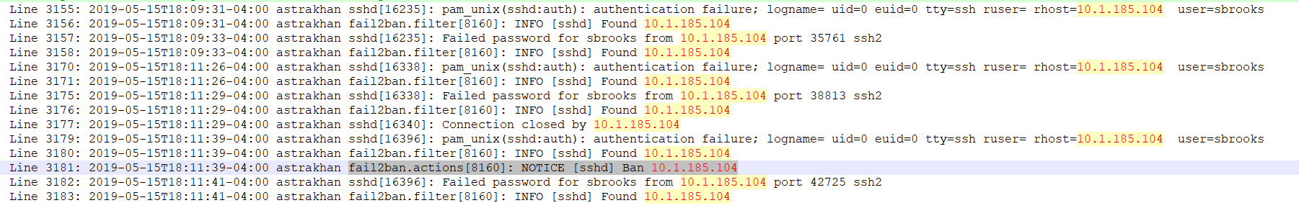

Team 1, Team 5, and red team all tried to use ssh to gain access to Astrakhan. However none of them were successful, the first ssh from team 1 10.1.185.14 tried to login as zathras which didn't exist on the computer. Team 5 repeatedly tried to login as sbrooks and were eventually banned by fail2ban, Red team were trying users that didn't exist on the machine, and eventually gave up. Finally another attacker from team 1 tried to brute force the user sbrooks and was banned after 5 unsuccessful logins (banning shown in the picture above).

### voronezh

**System Builder:** Jacob Kokai-Kun

**Role:** MySQL & SSH

**IP Address:** 10.4.161.79

**Production:**

Voronezh was produced on the cloud internal network using a Mint 17.1 disto and was meant to be a MySQL database for Astrakhans Wordpress site. The setup was fairly simple just required making the users for ssh and installing Mysql. Then just making sure a user and a database existed for wordpress to connect to and use

**Hardening:**

After creating the users for ssh I ensured that none of them had sudo privileges so if an account was breached the damage would be limited, also disabling ssh as root. For mysql the root user was disallowed from remote login and the users created for the database were only given privileges to read from the database, not to add or delete data. Finally fail2ban was installed on the system to lock out any brute force attacks.

**System Performance During Exercise:**

Voronezh and its services remained up for the duration of both days.

**Post-Activity Log Analysis:**

|  |  |  |  |  |  |
| --- | --- | --- | --- | --- | --- |
| **Time** | **Offending IP/Team** | **Repeated attempts** | **Information** | **Image Number** | |
| 5:26 Day 2 | 10.1.185.101/Team 1 | 1 | pam_unix(sshd:auth): authentication failure; logname= uid=0 euid=0 tty=ssh ruser= rhost=10.1.185.14 | |  |
| 5:28 | 10.1.185.101/Team 1 | 1 | Invalid user zathras from 10.1.185.101 | |  |
| 6:28 | 10.1.185.101/Team 1 | 1 | Failed password for root from 10.1.185.101 port 46727 ssh2 | |  |

The only attack on the system if it can even be called that was by team 1 who tried to login through ssh using root and zathras, presumably with the password “password1!” just to see if they could gain access that way. However as previously mentioned zathras never existed on the machine and the root password was set to a secure 16 character password. after these two failed attempts there was no more activity from this ip address and no evidence of attacks from any other teams.

### bryansk

**System Builder:** Keenan Starstrom

**Role:** Joomla Server

**IP Address:** 10.4.161.228

**Production:**

This system was a 2012 R2 server set up as the web server for a Joomla Site using IIS, it also served standard web pages overs http and https, and had WinRM and psexec enabled

**Hardening:**

Hardening steps taken for this box were to remove the zathras account, change the administrator password, ensure the firewall was enabled and configured, disabling SMB1, and setting up the account lockout policy.

**System Performance During Exercise:**

The system performed well outside of the Joomla page itself not functioning due to difficulties when building the site. Outside of this all other checks remained functional throughout both days of the exercise.

**Post-Activity Log Analysis:**

Log analysis of the system showed no indicators of an attack beyond some failed authorization attempts and pings used for nmap scans.

### khabarovsk

**System Builder:** Keenan Starstrom

**Role:** Joomla Database

**IP Address:** 10.4.161.163

**Production:**

This system was an Ubuntu 12.04 box configured as the MySQL database for byransk’s Joomla site, in addition to having MySQL, the system was also required to use SSH.

**Hardening:**

Hardening steps taken for this box were to remove the zathras account, change the root password, ensure the firewall was enabled and configured, disabling the ability to SSH as root, and setting up fail2ban to prevent brute force attempts.

**System Performance During Exercise:**

The system performed at full capacity both days of the exercise, never having service go down.

**Post-Activity Log Analysis:**

Log analysis showed no evidence of a successful attack, only anomalous logs were of some failed authentication attempts and some nmap scan pings.

### ligma

**System Builder:** Curtis Smallwood

**Role:** Active Directory and DNS

**IP Address:** 10.4.161.55

**Production:** This machine was setup to run Windows Server 2016 with Active Directory and DNS services for the Cloud network.

**Hardening:**

Windows firewall rules were disabled for any “File and Printer Sharing” on this machine since no services required SMB. This machine was not being checked by Nagios so nearly all inbound traffic was set to be blocked with the exception of DNS. An account lockout rule was set through Group Policy to lockout any users after 3 failed login attempts for 75 minutes. SMBv1 was disabled through Powershell and was confirmed through Powershell as well.

**System Performance During Exercise:**

This machine stayed up the entire exercise and never had any checks go down. Thanks to SMBv1 being disabled, nobody was able to use the EternalBlue exploit on this machine which tends to be the only thing most students know how to do in this class. Therefore, nothing really happened to this machine during the exercise.

**Post-Activity Log Analysis:**There are many failed login attempts for most users from a machine that was identifying itself as “EXERCISECONTROL” but it was not coming from 10.0.6.150 which is actually Exercise Control. Below is a photo of one of many logs that look like this.  


## Ipfire

### mamont

**System Builder:** Ryan Russell

**IP Address:** 10.4.159.9

**Production:**

The original plan was to connect this system to beluga through a VPN; this did not work. The VPN was assumedly correctly configured, but it did not connect. As a result, the corp network was connected through DNS servers. Each host machine had an internal and DMZ DNS for this reason.

Additionally, I setup the Web Proxy on this firewall device. I configured the proxy to require a username and password to allow web traffic through.

**Rules:**

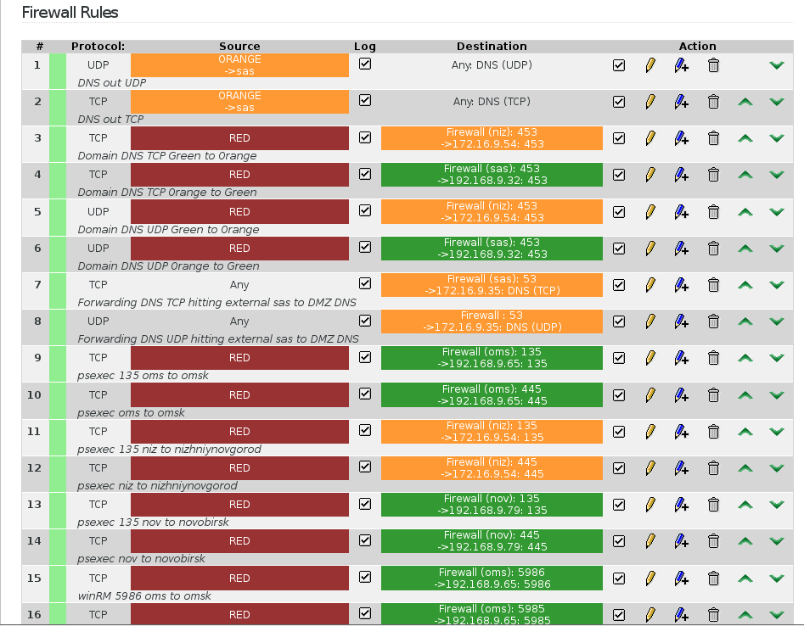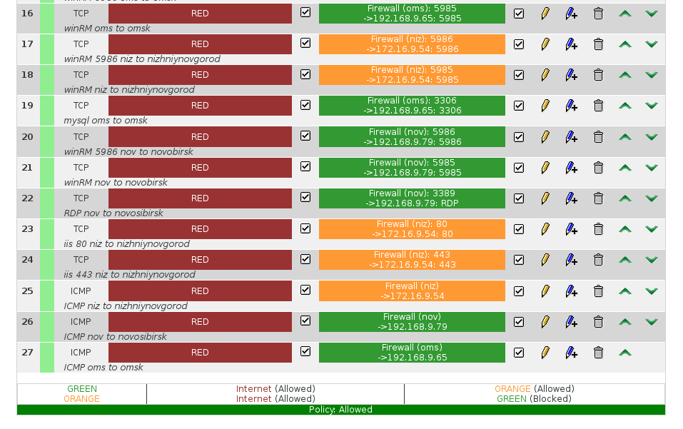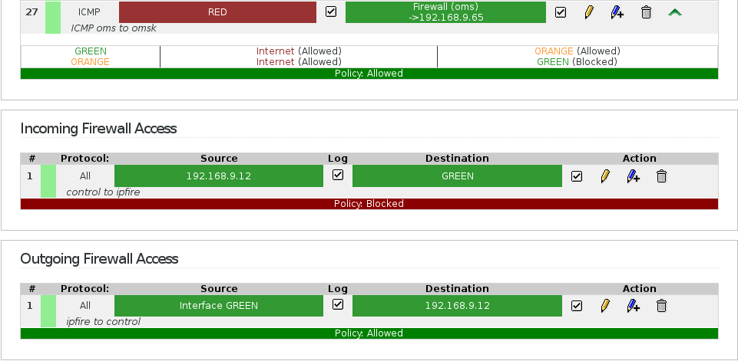

### beluga

**System Builder**: Carleigh Duncan

**IP Address:** 10.4.159.13

**Production**:

The original plan was to connect this system to Mamont through a VPN; this did not work. The VPN was assumedly correctly configured, but it did not connect. As a result, the corp network was connected through DNS servers. Each host machine had an internal and DMZ DNS for this reason.

**Rules**:

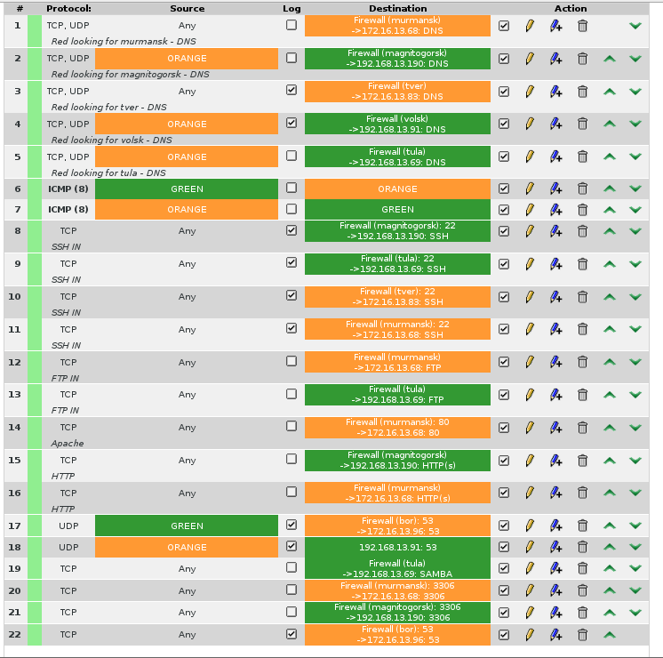

### mark

**System Builder:** Teresa Melgarejo

**IP Address:** 10.4.55.16

**Production:**

This machine was the IPFire box for the Production network. It hosted the DMZ (172.16.16.0/24) and Internal (192.168.16.0/24) networks.

**Rules:**

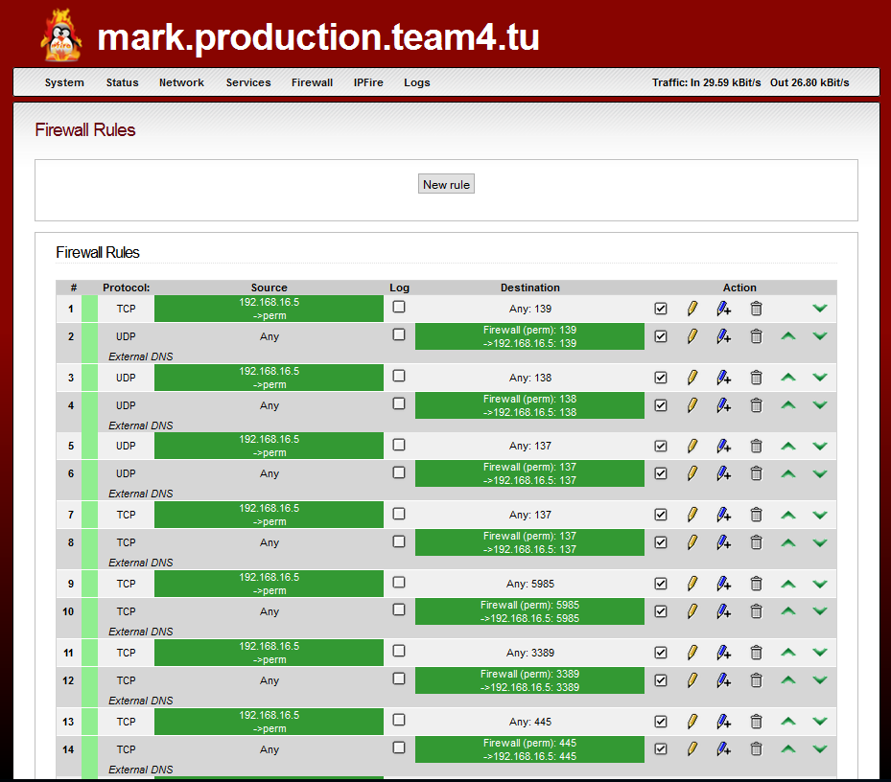

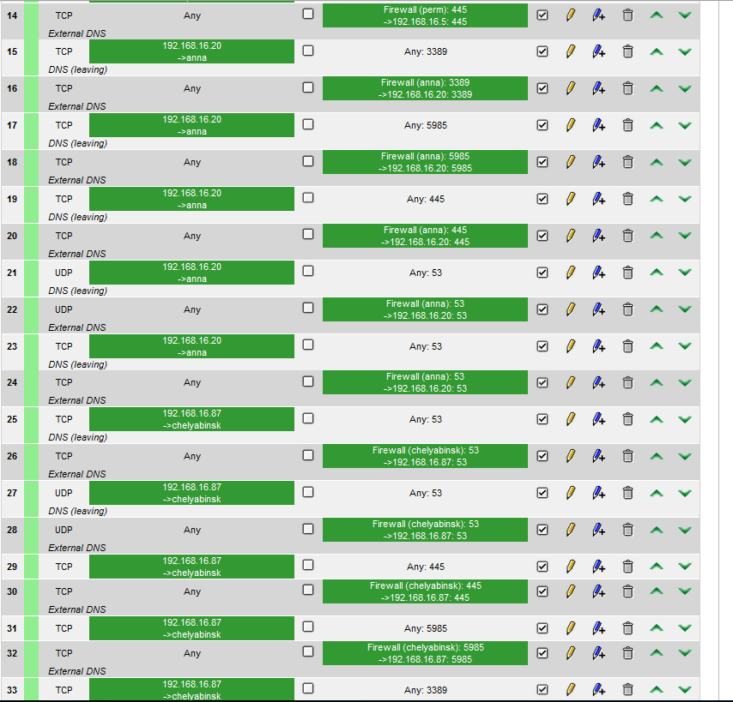

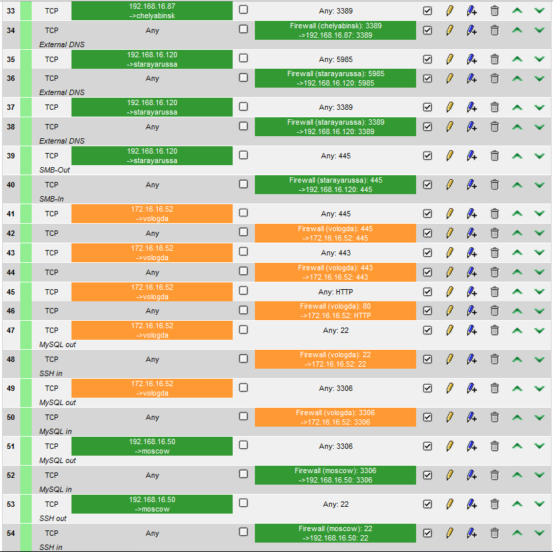

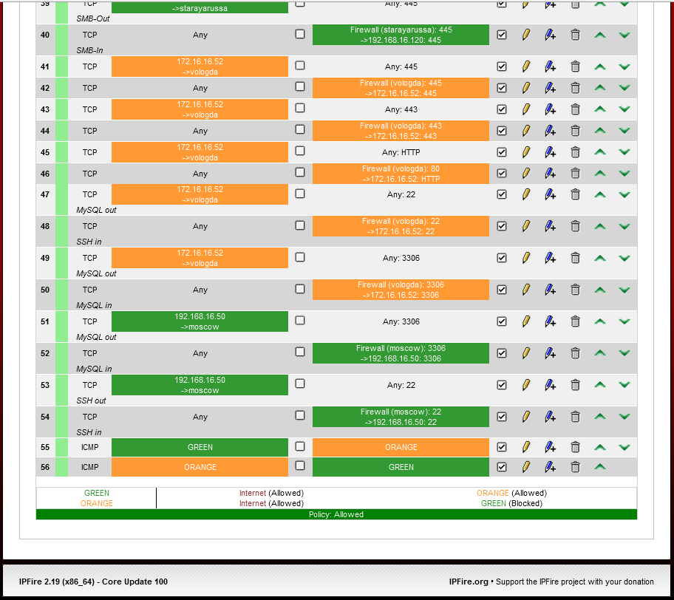

### chatam

**System Builder:** Curtis Smallwood

**IP Address:** 10.4.90.8

**Production:**

This machine was the IPFire box for the entire Cloud network. It hosted the DMZ (172.16.8.0/24) and Internal (192.168.8.0/24) networks.

**Rules:**

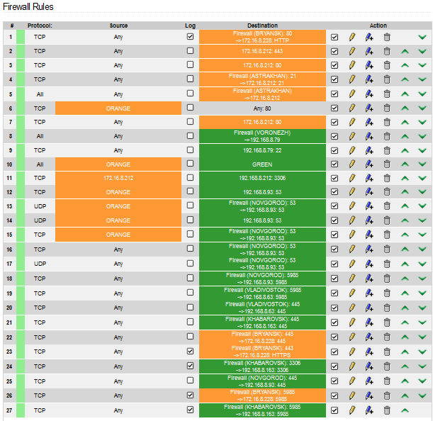

### stoli

**System Builder:** Curtis Smallwood

**IP Address:** 10.4.176.14

**Production:**

This machine was the IPFire box to access the sales network.

**Rules:**

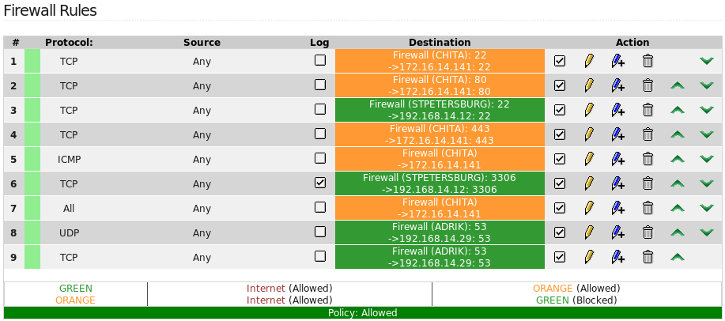

### zyr

**System Builder:** Brittany Galata

**IP Address:** 10.4.176.15

**Production:**

The original plan was to connect this system to putinka and stoli through a VPN; this did not work. The VPN was assumedly correctly configured, but it did not connect. As a result, the sales network was connected through DNS servers. Each host machine had an internal and DMZ DNS for this reason.

**Rules:**

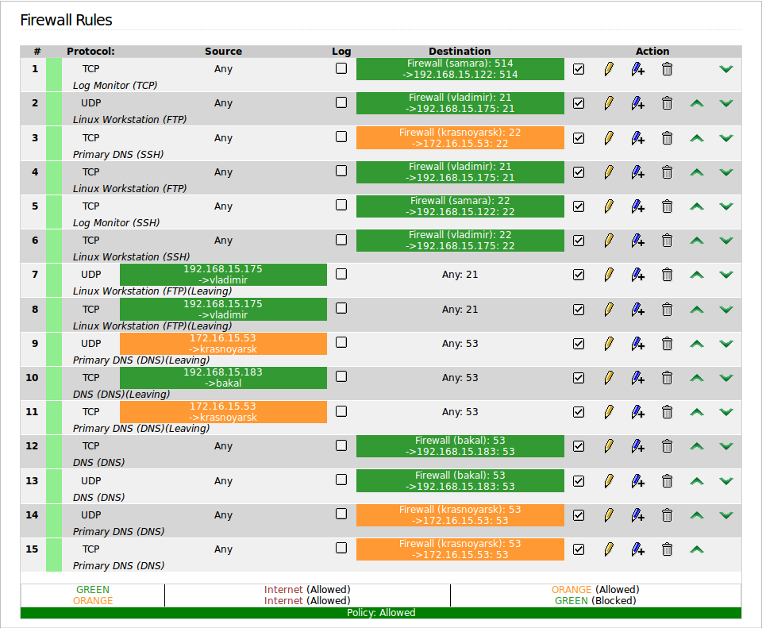

### putinka

**System Builder:** Jacob Kokai-Kun

**IP Address:** 10.4.176.11

**Production:**

Putinka was a ipfire box on the sales network with Magadan in the dmz and Saratov in the internal network. since neither of these two boxes required VPN’s to anyone else's machines all that was required was to set up rules so they could communicate with each other and outside machines.

**Rules:**

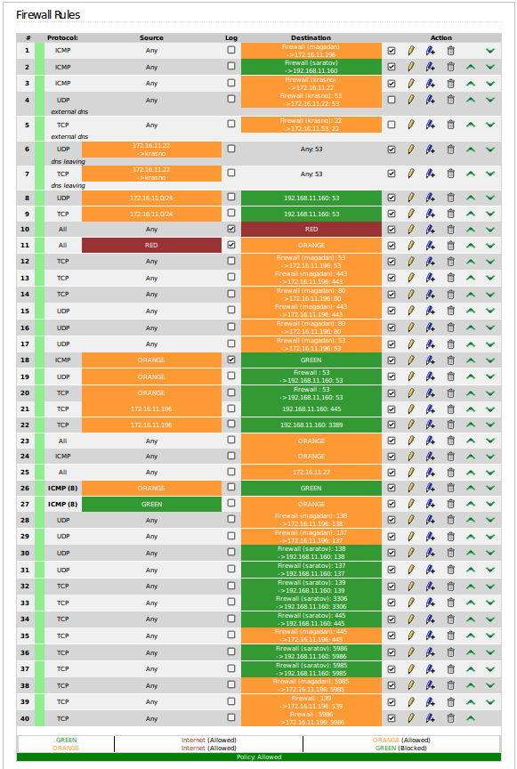

### ruskova

**System Builder:** Keenan Starstrom

**IP Address:** 10.4.55.10

**Production:**  This system was the IPfire box for the systems on my physical host, it served the 192.168.10.0/24 and 172.16.10.0/24 subnets.

**Rules:**

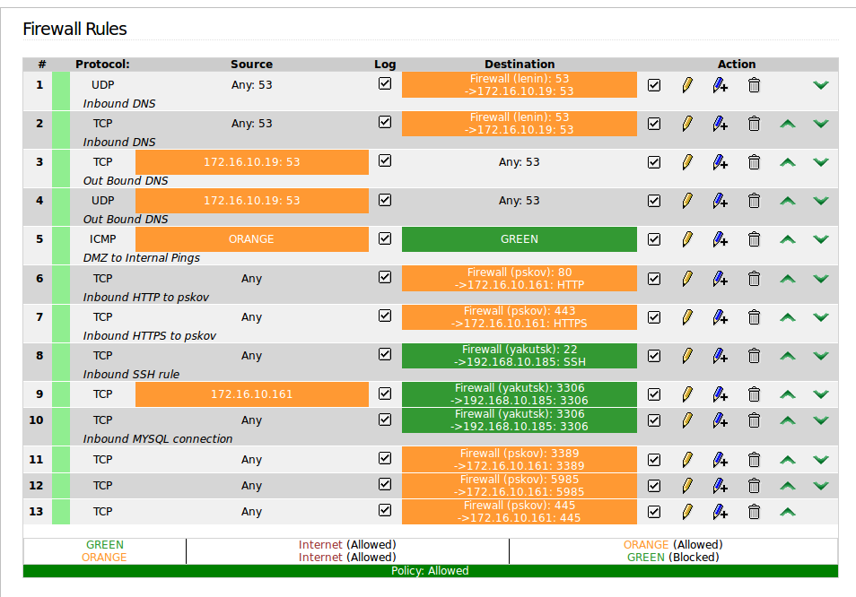

# offense

### nmap scans

**Team 1 Sales**

|  |  |  |  |
| --- | --- | --- | --- |
| **IP** | **Name** | **OS** | **Services** |
| 10.1.117.12 | canterbury.sales.team1.tu | Linux 2.6.32 | ssh, shell |
| 10.1.117.21 | dover.sales.team1.tu | Windows Server 2008 | msrpc, microsoft-ds, MySQL |
| 10.1.117.98 | liverpool.sales.team1.tu | Linux 2.6.32 | ftp, ssh |
| 10.1.117.139 | coventry.sales.team1.tu | Linux 3.11 - 4.1 | apache (http, https) |
| 10.1.117.157 | hastings.sales.team1.tu | Linux 3.2 - 3.8 | ssh, MySQL |
| 10.1.117.181 | newcastle.sales.team1.tu | Linux 2.6.32|Linux 2.6.32 or 3.10 | ssh, dns |
| 10.1.117.189 | surrey.sales.team1.tu | Microsoft Windows Server 2012 | dns, kerberos, msrpc |
| 10.1.117.245 | plymouth.sales.team1.tu |  |  |

**Team 2 Sales**

|  |  |  |  |
| --- | --- | --- | --- |
| **IP** | **Name** | **OS** | **Services** |
| 10.2.81.40 | krefeld.sales.team2.tu | Linux 2.6.32 | ssh |
| 10.2.81.49 | recklinghausen.sales.team2.tu | server 2016 | mysql |
| 10.2.81.161 | kassel.sales.team2.tu | Linux 3.11 - 4.1 | ssh, shell |
| 10.2.81.195 | saarbrucken.sales.team2.tu | Linux 2.6.32 | ssh, http, https |
| 10.2.81.226 | wolfsburg.sales.team2.tu | Linux 2.6.32 | ssh |
| 10.2.81.229 | hagen.sales.team2.tu | Linux 3.2 - 3.8 | http, https, mysql |
| 10.2.81.246 | osnabruck.sales.team2.tu | server 2012 | http, msrcp |

**Team 3** **All** (note team 3’s cloud network was never up which is why it is not included)

|  |  |  |  |
| --- | --- | --- | --- |
| **IP** | **Name** | **OS** | **Services** |
| 10.3.1.54 | hongsawadee.production.team3.tu | windows server 2012 | msrpc, netbios-ssn,microsoft-ds |
| 10.3.1.77 | khankaen.production.team3.tu | linux 2.6.32 | ssh |
| 10.3.1.79 | n.a. | server 2012 | domain, msrpc, ldap, http |
| 10.3.1.179 | ayutthaya.production.team3.tu | server 2012 r2 | http, msrpc, https |
| 10.3.1.242 | nakhonchum.production.team3.tu | Linux 3.11 - 4.1 | ssh, http, https |
| 10.3.5.38 | ratchasima.corp.team3.tu | (couldn't tell) | ms-wbt-server |
| 10.3.5.76 | n.a. | linux 3.11 | ssh, mysql |
| 10.3.5.78 | nakhonsithammarat.corp.team3.tu | server 2008 | http, https |
| 10.3.5.82 | n.a. | linux 4.1 | ssh, domain |
| 10.3.5.90 | uttaradit.corp.team3.tu | server 2008 | https, mysql |
| 10.3.5.169 | vientiane.corp.team3.tu | linux 3.2 | ftp, ssh, http, https |
| 10.3.5.229 | phrae.corp.team3.tu | linux 3.2 - 3.8 | ftp, ssh |
| 10.3.109.99 | tak.sales.team3.tu | server 2008 | http, https |
| 10.3.109.165 | n.a. | linux 2.6.32 | ssh |
| 10.3.109.179 | n.a. | linux 2.6.32 | ssh |
| 10.3.109.205 | n.a. | linux 3.11 | ssh, mysql |
| 10.3.109.209 | n.a. | kunux 3.11 | ssh |

**Team 5 corp**

|  |  |  |  |
| --- | --- | --- | --- |
| **IP** | **Name** | **OS** | **Services** |
| 10.5.110.48 | torodi.corp.team5.tu |  |  |
| 10.5.110.50 | baguette.corp.team5.tu |  |  |
| 10.5.110.51 | bag.corp.team5.tu |  |  |
| 10.5.110.93 | chien.corp.team5.tu |  |  |
| 10.5.110.108 | walata.corp.team5.tu |  |  |
| 10.5.110.122 | tadmekket.corp.team5.tu |  |  |
| 10.5.110.137 | ouatagouna.corp.team5.tu |  |  |
| 10.5.110.162 | tekedda.corp.team5.tu |  |  |
| 10.5.110.171 | tombouctu.corp.team5.tu |  |  |
| 10.5.110.250 | agadez.corp.team5.tu |  |  |

### 10.4.12.23

**System Builder:** Jacob Kokai-Kun

**Role:** Kali Linux

**Attacks:**

I primarily focused on attacking team 3, after performing an nmap scan on them I looked for windows machines vulnerable to eternal blue. This allowed me to get a shell on two of their machines. 10.3.1.176, and 10.3.109.99 (tak).

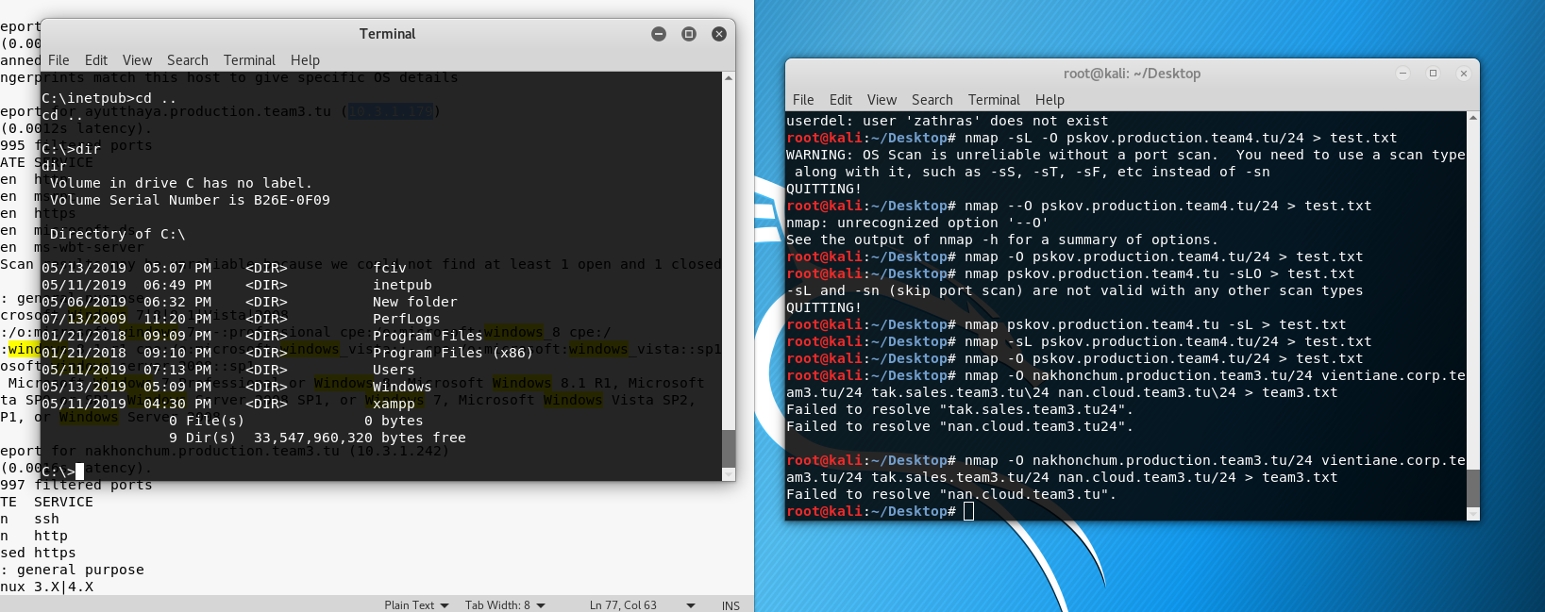

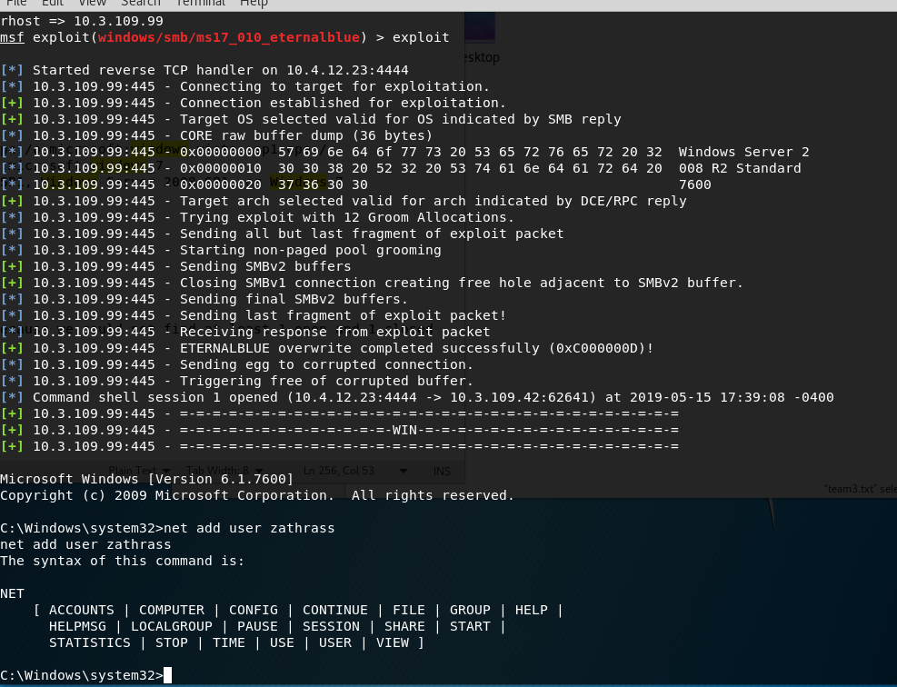

once on the machines I was primarily trying to delete files that would bring checks down. On tak for example I deleted php and phpMyAdmin

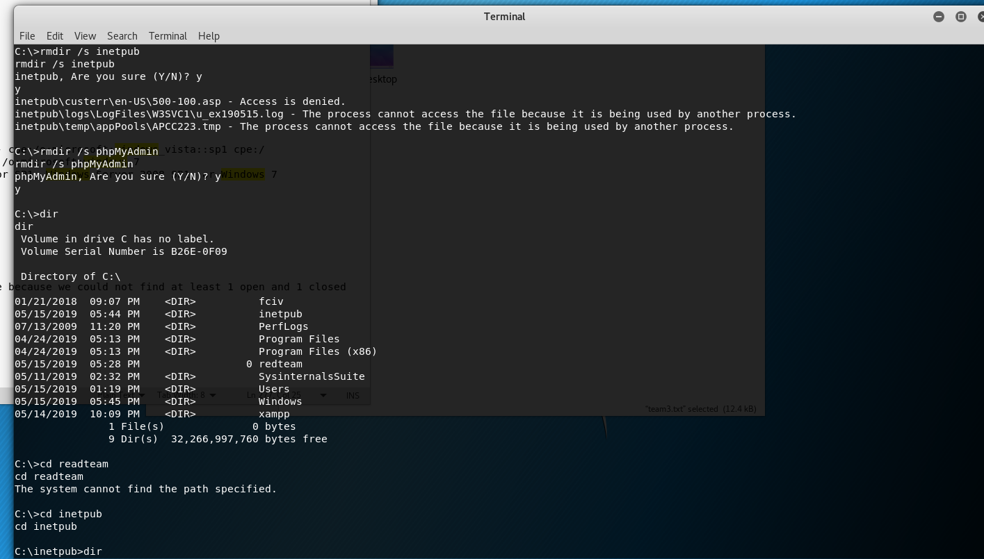

Then made a user called “hello” and added them to the administrators group

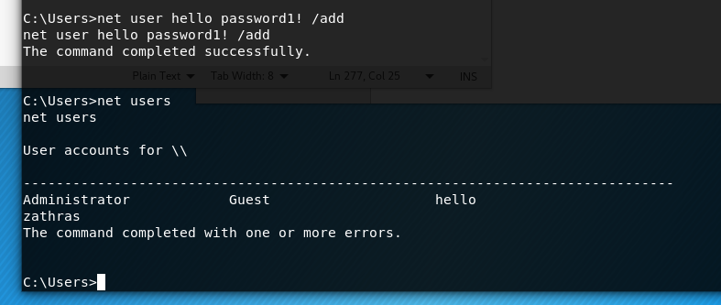

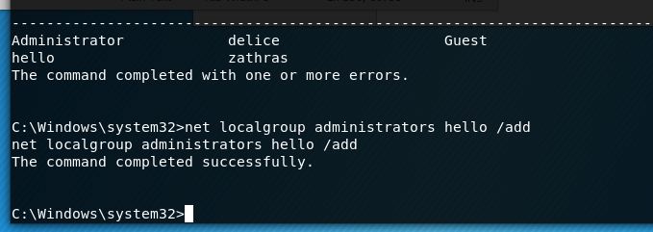

Other teams besides team 3 had defenses set up against eternal blue and changed their passwords so I was unable to gain access to any other machines through metasploit. In addition to the metasploit modules I also tried ssh’ing into a couple of machines with zathras and root using the password “password1!” however this didn't work for any of the machines I tried on teams 1, 2, or 5.

### 10.4.8.13

**System Builder:** Curtis Smallwood

**Role:** Kali Linux

**Attacks:** Only used to gather credentials or run nmap scans. I did not connect to any machines with this Kali box.

### 10.4.8.13

**System Builder:** Curtis Smallwood

**Role:** Kali Linux

**Attacks:** I used the Kali machine with the IP of 10.4.8.10 to run nmap scans of other teams. Once I gathered information from them, I looked through for MySQL databases and then ran the mysql brute force scanner with the known user and the master password list. Once I discovered a the password for that user, I checked nagios for systems that had that user listed in any checks. I then would login via ssh to Linux machines with that username and password from this machine. See some photos below:  
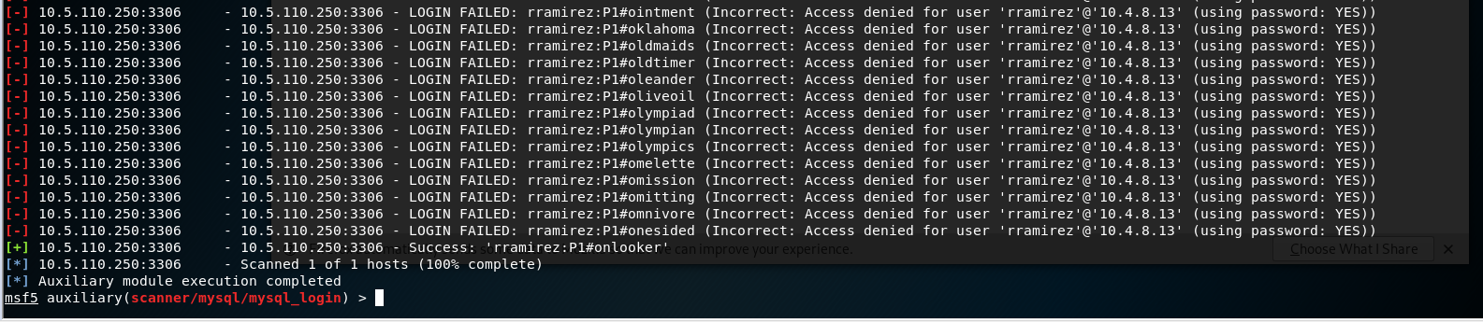

After logging in with the password found:  
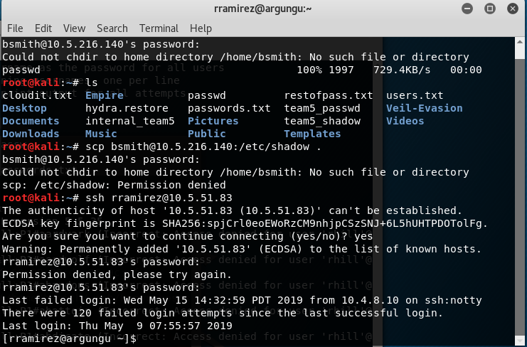

Once I logged into this machine, I was able to scp the Team5Personal.csv back to my Kali machine. See photo below:  
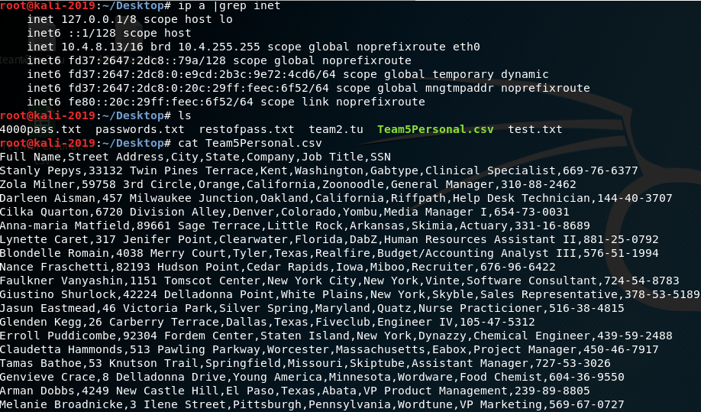

On Day 1 I was able to login to 10.5.216.140, a Team 5 Linux webserver as root with “password1!” as the password. I removed the Apache service to break their checks while I was in there.  
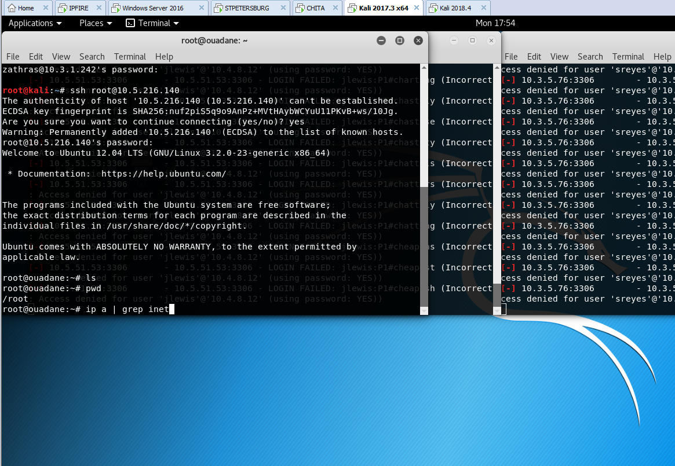

Removing Apache:  
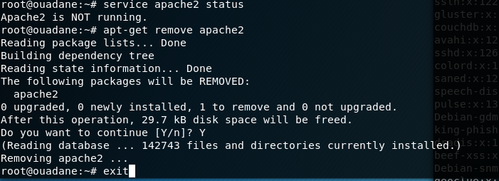

I found a server with the IP of 10.3.1.179 on Team 3 that was running SMBv1 on port 445 so I was able to successfully launch an Eternal Blue exploit. It turns out this was an IIS Webserver so I deleted their wwwroot directory which broke their checks. While I was in there I watched another service delete the CA Certs from the certs folder so that was interesting to see that many un-authorized were currently tearing apart this machine.  
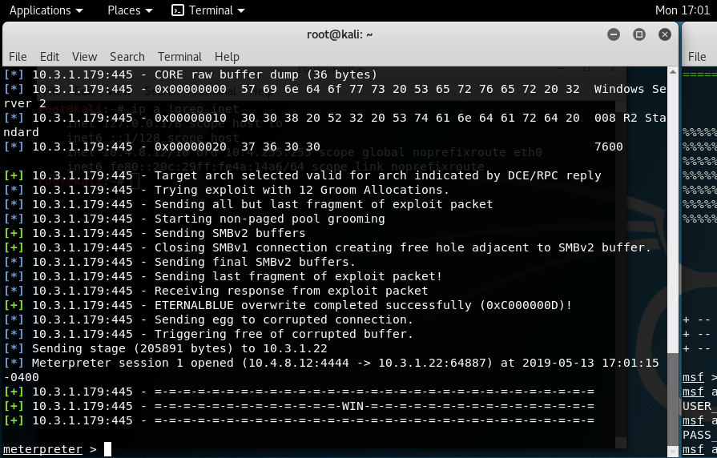

Throughout the exercise on day 2, I continued to run the MySQL brute force attack and gain access to other teams machines as non-privileged users. I would just delete the authorized_keys file and reset the user’s passwords while I was there to break their Nagios checks.

### 10.4.49.57

**System Builder:** Brittany Galata

**Role:** Kali Linux

**Attacks:**

SMBv1 was not disabled on team 3’s tak.sales.team3.tu system allowing an eternal blue attack to be performed against **10.3.109.99**. Below, it can be seen that metasploit was used to exploit the system when the rhost was set to 10.3.109.99. A shell was gained allowing access to the system. An admin user was then created, which is explained further below.

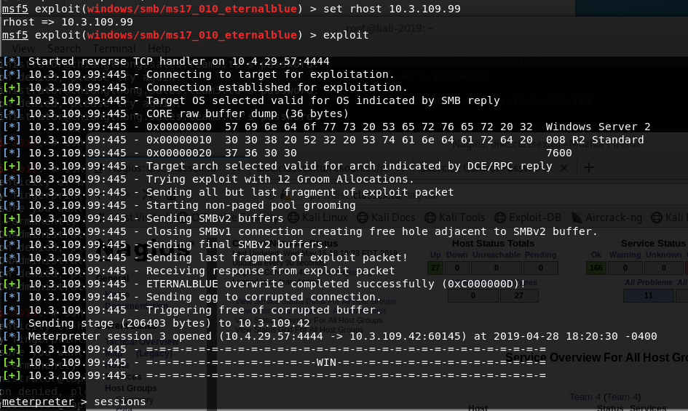

An admin user was then created with the user named “delice” and a password of “password1!” on **10.3.109.99**.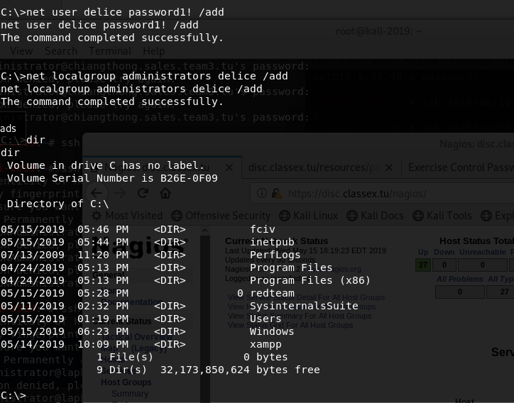

Zone transfers were not disabled for **10.3.4.82** which is one of team 3’s bind DNS servers on the corp network. Was able to easily grab team 3’s entire corp network and the full version of the bind DNS server.

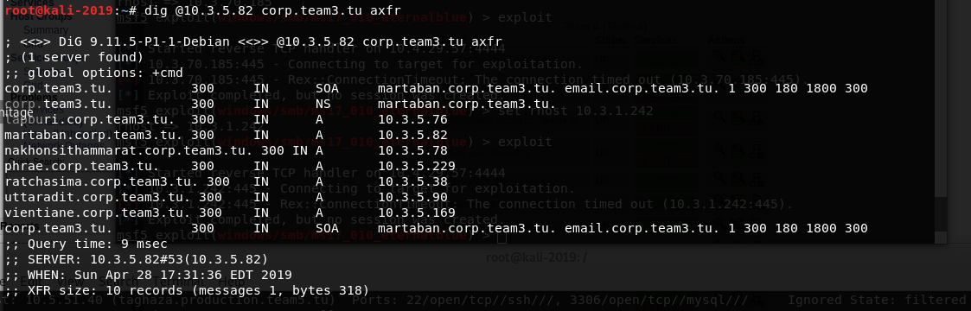

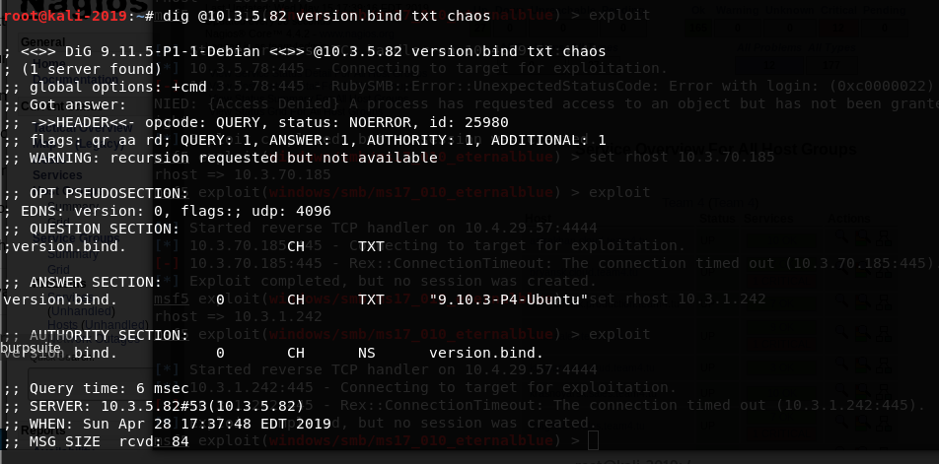

Zone transfers were not disabled for **10.3.109.165** which is one of team 3’s bind DNS servers on the sales network. Was able to easily grab team 3’s entire sales network and the full version of the bind DNS server.

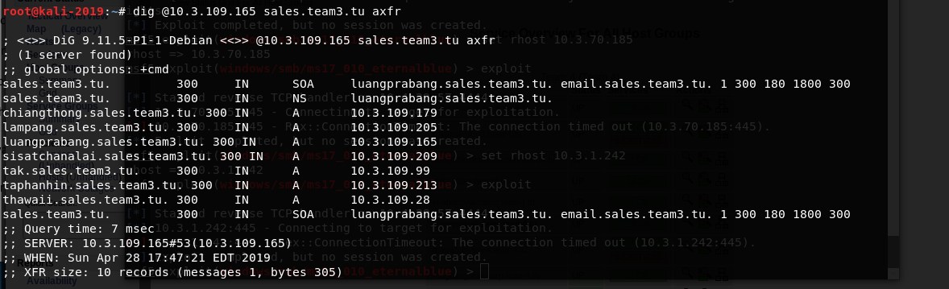

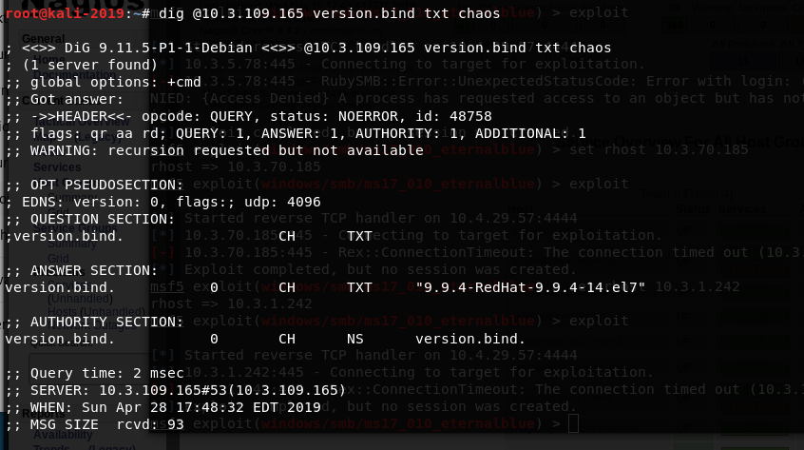

### 

### 10.4.49.83

**System Builder:** Teresa Melgarejo

**Role:** Kali Linux

**Attacks:** I used the Kali machine with IP of **10.4.49.83** to run nmap scans of other teams. Each member of offense decided who they’d be focusing on, I was focusing on Team 3. Once I gathered information from them, I ran eternal blue on any of the Windows systems I found in the nmap results. Since more than one member was focusing on team 3, we told each other the IPs we managed to get into, to ensure not to waste any time. Without looking at hostnames, but just IPs, I ran eternal blue on **10.3.109.42** (configures to a DMZ IP) as shown below:

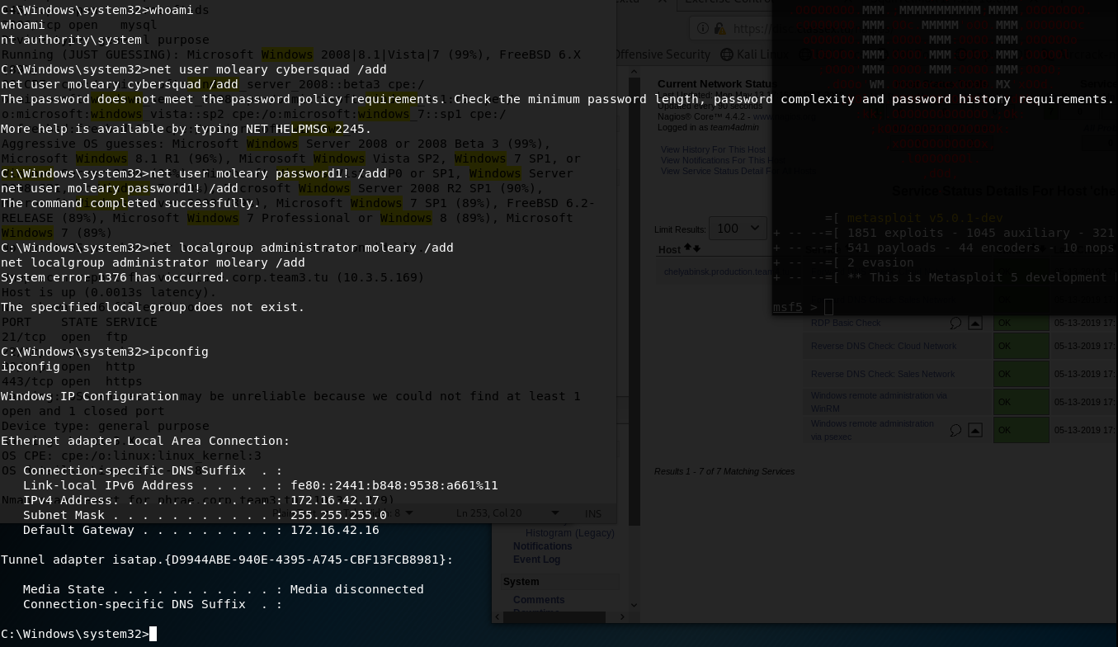

Once I was in, I added a user called **moleary** with the password **password1!** and then I added that user to the Administrator group. After doing all that, I realized I should probably check for hostname, I forgot to check for it on the command prompt, but I looked in the nmap scans that had hostnames for any of the systems set with one. When I went to the nmap scans to check, I saw it didn’t have one. I thought that was odd, then I realized it was probably a system on Red Team.

Later on Day 1, I began attempting to SSH into system as either root or zathras to see if anyone forgot to change their passwords from **password1!** and I was able to get into a CA signing box as user **zathras** on **banphai.production.team3.tu.** Once I was in their box, I deleted any certificates and signing requests I could find. After deleting everything, I attempted to reboot from the terminal but was unsuccessful since **zathras** was not a sudoer. The terminal without the reboot attempt is shown below:

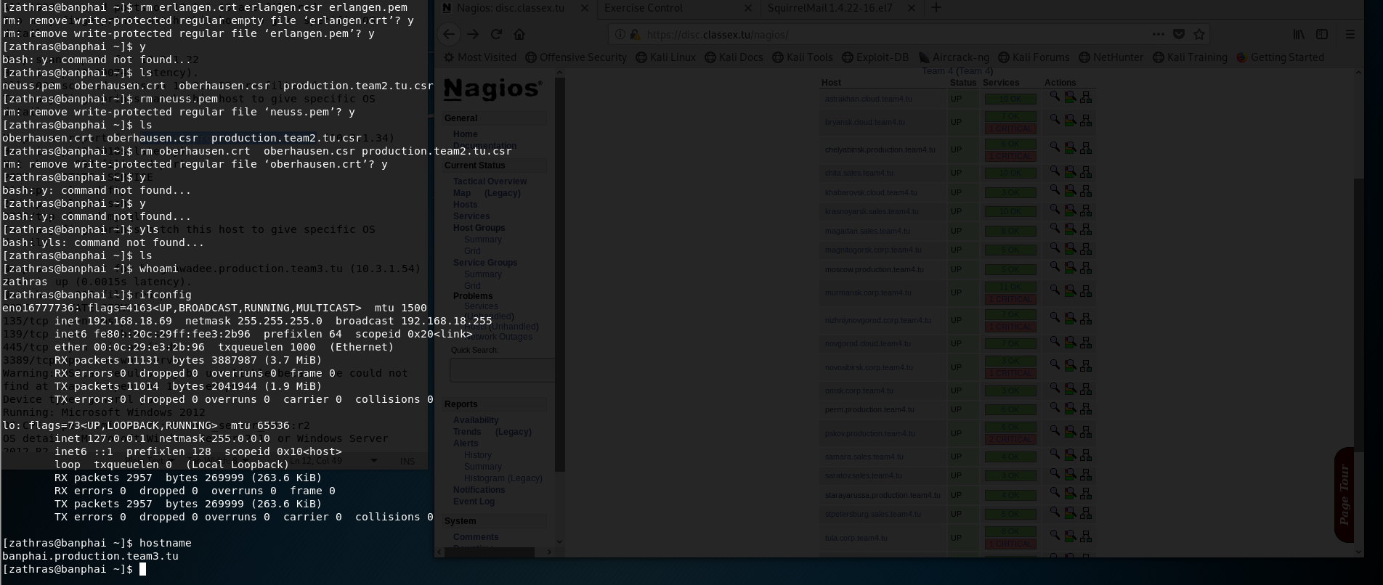

### 

### 10.4.159.65

**System Builder:** Ryan

**Role:** Kali Linux

**Attacks:**

I performed several Nmap scans on the first day.

Team 1’s network where their known DNS was located:

|  |
| --- |
| # Nmap 7.70 scan initiated Mon May 13 17:07:32 2019 as: nmap -sP -oG team1-DNS 10.1.117.1-254 Host: 10.1.117.12 (canterbury.sales.team1.tu) Status: Up Host: 10.1.117.21 (dover.sales.team1.tu) Status: Up Host: 10.1.117.98 (liverpool.sales.team1.tu) Status: Up Host: 10.1.117.139 (coventry.sales.team1.tu) Status: Up Host: 10.1.117.157 (hastings.sales.team1.tu) Status: Up Host: 10.1.117.181 (newcastle.sales.team1.tu) Status: Up Host: 10.1.117.189 (surrey.sales.team1.tu) Status: Up Host: 10.1.117.245 (plymouth.sales.team1.tu) Status: Up # Nmap done at Mon May 13 17:07:37 2019 -- 254 IP addresses (8 hosts up) scanned in 4.38 seconds |

An OS scan of Team 1’s network where their known DNS was located:

|  |
| --- |
| # Nmap 7.70 scan initiated Mon May 13 17:12:12 2019 as: nmap -O -oG team1-DNS-OS 10.1.117.12 10.1.117.21 10.1.117.98 10.1.117.139 10.1.117.157 10.1.117.181 10.1.117.189 10.1.117.249 Host: 10.1.117.12 (canterbury.sales.team1.tu) Status: Up Host: 10.1.117.12 (canterbury.sales.team1.tu) Ports: 22/open/tcp//ssh///, 514/open/tcp//shell/// Ignored State: filtered (998) OS: Linux 2.6.32 Seq Index: 260 IP ID Seq: All zeros Host: 10.1.117.21 (dover.sales.team1.tu) Status: Up Host: 10.1.117.21 (dover.sales.team1.tu) Ports: 135/open/tcp//msrpc///, 445/open/tcp//microsoft-ds///, 3306/open/tcp//mysql///, 49153/open/tcp//unknown///, 49154/open/tcp//unknown/// Ignored State: filtered (995) OS: Microsoft Windows Server 2008 or 2008 Beta 3|Microsoft Windows Server 2008 R2 or Windows 8.1|Microsoft Windows 7 Professional or Windows 8|Microsoft Windows Embedded Standard 7|Microsoft Windows 8.1 R1|Microsoft Windows Phone 7.5 or 8.0|Microsoft Windows Vista SP0 or SP1, Windows Server 2008 SP1, or Windows 7|Microsoft Windows Vista SP2, Windows 7 SP1, or Windows Server 2008 Seq Index: 260 IP ID Seq: Incremental Host: 10.1.117.98 (liverpool.sales.team1.tu) Status: Up Host: 10.1.117.98 (liverpool.sales.team1.tu) Ports: 21/open/tcp//ftp///, 22/open/tcp//ssh/// Ignored State: filtered (998) OS: Linux 2.6.32 Seq Index: 258 IP ID Seq: All zeros Host: 10.1.117.139 (coventry.sales.team1.tu) Status: Up Host: 10.1.117.139 (coventry.sales.team1.tu) Ports: 80/open/tcp//http///, 443/open/tcp//https/// Ignored State: filtered (998) OS: Linux 3.11 - 4.1 Seq Index: 264 IP ID Seq: All zeros Host: 10.1.117.157 (hastings.sales.team1.tu) Status: Up Host: 10.1.117.157 (hastings.sales.team1.tu) Ports: 22/open/tcp//ssh///, 3306/open/tcp//mysql/// Ignored State: closed (998) OS: Linux 3.2 - 3.8 Seq Index: 256 IP ID Seq: All zeros Host: 10.1.117.181 (newcastle.sales.team1.tu) Status: Up Host: 10.1.117.181 (newcastle.sales.team1.tu) Ports: 22/open/tcp//ssh///, 53/open/tcp//domain/// Ignored State: filtered (998) OS: Linux 2.6.32|Linux 2.6.32 or 3.10 Seq Index: 257 IP ID Seq: All zeros Host: 10.1.117.189 (surrey.sales.team1.tu) Status: Up Host: 10.1.117.189 (surrey.sales.team1.tu) Ports: 53/open/tcp//domain///, 88/open/tcp//kerberos-sec///, 135/open/tcp//msrpc///, 139/open/tcp//netbios-ssn///, 389/open/tcp//ldap///, 445/open/tcp//microsoft-ds///, 464/open/tcp//kpasswd5///, 593/open/tcp//http-rpc-epmap///, 636/open/tcp//ldapssl///, 3268/open/tcp//globalcatLDAP///, 3269/open/tcp//globalcatLDAPssl///, 49154/open/tcp//unknown///, 49155/open/tcp//unknown///, 49157/open/tcp//unknown///, 49158/open/tcp//unknown///, 49159/open/tcp//unknown/// Ignored State: filtered (984) OS: Microsoft Windows Server 2012 or Windows Server 2012 R2 Seq Index: 258 IP ID Seq: Incremental # Nmap done at Mon May 13 17:12:35 2019 -- 8 IP addresses (7 hosts up) scanned in 23.21 seconds |

A mySQL port scan of every known subnet for Team 1 (the subnet info was gathered by other team members):

|  |
| --- |
| # Nmap 7.70 scan initiated Mon May 13 17:43:50 2019 as: nmap -p3306 -oG team1-mySQL 10.1.117.0/24 10.1.95.0/24 10.1.21.0/24 10.1.180.0/24 Host: 10.1.117.12 (canterbury.sales.team1.tu) Status: Up Host: 10.1.117.12 (canterbury.sales.team1.tu) Ports: 3306/filtered/tcp//mysql/// Host: 10.1.117.21 (dover.sales.team1.tu) Status: Up Host: 10.1.117.21 (dover.sales.team1.tu) Ports: 3306/open/tcp//mysql/// Host: 10.1.117.98 (liverpool.sales.team1.tu) Status: Up Host: 10.1.117.98 (liverpool.sales.team1.tu) Ports: 3306/filtered/tcp//mysql/// Host: 10.1.117.139 (coventry.sales.team1.tu) Status: Up Host: 10.1.117.139 (coventry.sales.team1.tu) Ports: 3306/filtered/tcp//mysql/// Host: 10.1.117.157 (hastings.sales.team1.tu) Status: Up Host: 10.1.117.157 (hastings.sales.team1.tu) Ports: 3306/open/tcp//mysql/// Host: 10.1.117.181 (newcastle.sales.team1.tu) Status: Up Host: 10.1.117.181 (newcastle.sales.team1.tu) Ports: 3306/filtered/tcp//mysql/// Host: 10.1.117.189 (surrey.sales.team1.tu) Status: Up Host: 10.1.117.189 (surrey.sales.team1.tu) Ports: 3306/filtered/tcp//mysql/// Host: 10.1.117.245 (plymouth.sales.team1.tu) Status: Up Host: 10.1.117.245 (plymouth.sales.team1.tu) Ports: 3306/filtered/tcp//mysql/// Host: 10.1.95.42 (richmond.cloud.team1.tu) Status: Up Host: 10.1.95.42 (richmond.cloud.team1.tu) Ports: 3306/filtered/tcp//mysql/// Host: 10.1.95.76 (bath.cloud.team1.tu) Status: Up Host: 10.1.95.76 (bath.cloud.team1.tu) Ports: 3306/open/tcp//mysql/// Host: 10.1.95.77 (salisbury.cloud.team1.tu) Status: Up Host: 10.1.95.77 (salisbury.cloud.team1.tu) Ports: 3306/filtered/tcp//mysql/// Host: 10.1.95.101 (york.cloud.team1.tu) Status: Up Host: 10.1.95.101 (york.cloud.team1.tu) Ports: 3306/open/tcp//mysql/// Host: 10.1.95.184 (colchester.cloud.team1.tu) Status: Up Host: 10.1.95.184 (colchester.cloud.team1.tu) Ports: 3306/filtered/tcp//mysql/// Host: 10.1.95.203 (oxford.cloud.team1.tu) Status: Up Host: 10.1.95.203 (oxford.cloud.team1.tu) Ports: 3306/filtered/tcp//mysql/// Host: 10.1.21.10 (cambridge.corp.team1.tu) Status: Up Host: 10.1.21.10 (cambridge.corp.team1.tu) Ports: 3306/filtered/tcp//mysql/// Host: 10.1.21.12 (brixton.corp.team1.tu) Status: Up Host: 10.1.21.12 (brixton.corp.team1.tu) Ports: 3306/filtered/tcp//mysql/// Host: 10.1.21.14 (portsmouth.corp.team1.tu) Status: Up Host: 10.1.21.14 (portsmouth.corp.team1.tu) Ports: 3306/open/tcp//mysql/// Host: 10.1.21.19 (birmingham.corp.team1.tu) Status: Up Host: 10.1.21.19 (birmingham.corp.team1.tu) Ports: 3306/open/tcp//mysql/// Host: 10.1.21.65 (warwick.corp.team1.tu) Status: Up Host: 10.1.21.65 (warwick.corp.team1.tu) Ports: 3306/filtered/tcp//mysql/// Host: 10.1.21.73 (exeter.corp.team1.tu) Status: Up Host: 10.1.21.73 (exeter.corp.team1.tu) Ports: 3306/filtered/tcp//mysql/// Host: 10.1.21.151 (leicester.corp.team1.tu) Status: Up Host: 10.1.21.151 (leicester.corp.team1.tu) Ports: 3306/filtered/tcp//mysql/// Host: 10.1.21.212 (gloucester.corp.team1.tu) Status: Up Host: 10.1.21.212 (gloucester.corp.team1.tu) Ports: 3306/filtered/tcp//mysql/// Host: 10.1.180.13 () Status: Up Host: 10.1.180.13 () Ports: 3306/filtered/tcp//mysql/// Host: 10.1.180.37 () Status: Up Host: 10.1.180.37 () Ports: 3306/filtered/tcp//mysql/// Host: 10.1.180.51 (london.production.team1.tu) Status: Up Host: 10.1.180.51 (london.production.team1.tu) Ports: 3306/open/tcp//mysql/// Host: 10.1.180.52 (winchester.production.team1.tu) Status: Up Host: 10.1.180.52 (winchester.production.team1.tu) Ports: 3306/filtered/tcp//mysql/// Host: 10.1.180.61 (ipswich.production.team1.tu) Status: Up Host: 10.1.180.61 (ipswich.production.team1.tu) Ports: 3306/open/tcp//mysql/// Host: 10.1.180.62 (sandford.production.team1.tu) Status: Up Host: 10.1.180.62 (sandford.production.team1.tu) Ports: 3306/filtered/tcp//mysql/// Host: 10.1.180.101 (manchester.production.team1.tu) Status: Up Host: 10.1.180.101 (manchester.production.team1.tu) Ports: 3306/filtered/tcp//mysql/// Host: 10.1.180.113 (sheffield.production.team1.tu) Status: Up Host: 10.1.180.113 (sheffield.production.team1.tu) Ports: 3306/filtered/tcp//mysql/// Host: 10.1.180.175 (mumbles.production.team1.tu) Status: Up Host: 10.1.180.175 (mumbles.production.team1.tu) Ports: 3306/filtered/tcp//mysql/// Host: 10.1.180.184 (leeds.production.team1.tu) Status: Up Host: 10.1.180.184 (leeds.production.team1.tu) Ports: 3306/filtered/tcp//mysql/// Host: 10.1.180.251 () Status: Up Host: 10.1.180.251 () Ports: 3306/filtered/tcp//mysql/// # Nmap done at Mon May 13 17:44:03 2019 -- 1024 IP addresses (33 hosts up) scanned in 12.72 seconds |

This and similar scans were performed on every known subnet of the other teams.

On day two, I used the info previously gathered on day one by myself and other team members to perform attacks on other teams’ machines.

I started by targeted specific hosts belonging to Team 1 with a perl script that enumerates mySQL usernames on a specified machine. I did this on several hosts until I got a hit on several machines:

|  |
| --- |
| perl /usr/share/exploitdb/exploits/multiple/remote/23081.pl 10.1.117.157 [*] HIT! -- USER EXISTS: lstephens@10.1.117.157 |

and

|  |
| --- |
| perl /usr/share/exploitdb/exploits/multiple/remote/23081.pl 10.1.117.21 [*] HIT! -- USER EXISTS: lstephens@10.1.117.157 |

I then targeted the same hosts with mySQL brute force attacks: (history shown)

|  |
| --- |
| 7 use auxiliary/scanner/mysql/mysql_login  8 info 9 set username lstephens 10 set pass_file /root/Desktop/passwords 11 set rhosts 10.1.117.157 12 set verbose false 13 exploit 14 creds |

I performed the same attack on the machine with the IP address of 10.1.117.21. After failing both times to find a working password, I created downloaded the password list form Exercise Control and configured the metasploit module to use both a username list and a password list. This took almost an hour to complete on both machines and did not return any successful results, making me curious if they had configured their mySQL user with a password from the password list.

Putting that attempt aside, I used several usernames form Team 5 that Curtis had obtained on day 1 of the exercise to narrow an SMB brute force attack on one of the Team 5 hosts that had been previously Nmapped (history shown):

|  |
| --- |
| 38 use auxiliary/scanner/smb/smb_login  39 info 40 set pass_file /root/Desktop/passwords 41 set smbuser cwelch 42 set rhosts 10.5.110.93 43 set threads 5 44 set verbose false 45 set smbdomain CORP 46 exploit |

This resulted in obtaining a working password for domain user jthompson on the Team 5 CORP network:

|  |
| --- |
| [+] 10.5.110.93:445 - SMB - Success: 'CORP\cwelch:P1#American' [*] Scanned 1 of 1 hosts (100% complete) [*] Auxiliary module execution completed |

I then searched through the Nmap scan results from the previous day, until I found several systems that had several Microsoft specific ports open and/or services running. I then tried to RDP into those machines until I successfully gained access to chien.corp.team5.tu at the IP address 10.5.110.93:

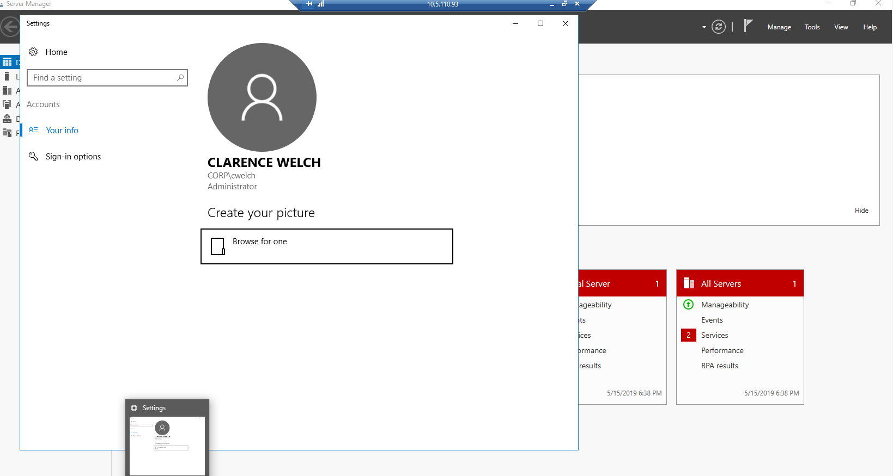

I added two users, one named Cheryl Brooks (cbrooks) and and another named Domain User, and added both to the Domain Admin and Administrators groups. I then removed all the other Domain Admins from that group,, and changed all their passwords. Meanwhile, Keenan was trying to join one of his spare Windows machines to Team 5’s Corp domain using the Domain Admin users I had created. However, the connection proved to be laggy, and Team 5 seemed to have restarted several of their computers during this process, interfering in our plan until class ended.

### 10.4.49.21

**System Builder:** Keenan Starstrom

**Role:** Kali Linux

**Attacks:**

Day 1 this system was used to get a full nmap scan of Team 1s network, to get the IPs of their boxes to attempt attacks.

Tried several different attacks against their network, checking for systems with SMB1 still enabled, trying to use a mysql exploit, but no success was had against their defenses. Day 2 after scanning for possible targets on team 2’s network, I was able to successfully use the EternalBlue exploit to open a shell on a 2008 R2 server.

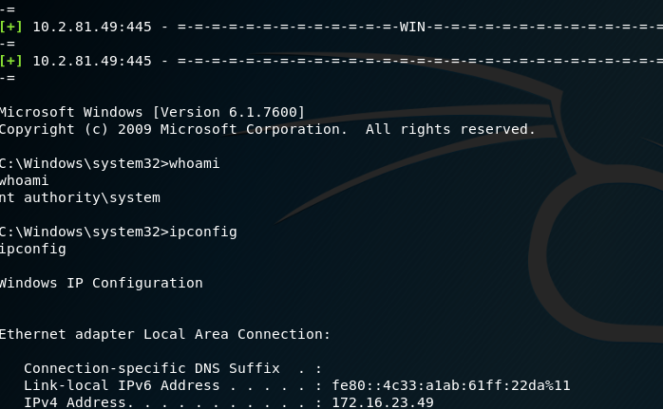

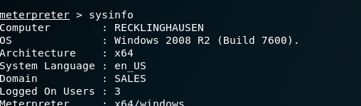

Unfortunately the team was monitoring their boxes and restarted the system before I was able to exploit the shell. After the restart they disabled SMB1 and I was unable to get back into the box. No other successful attacks were launched from this box on Day 2, although not for lack of trying.